EX.NO)1A SEQUENTIAL SEARCH

Aim:
To create a c program to search the element in an array using Sequential search algorithm.

Algorithm:

Step 1: Start the program.
Step 2: Declare the variables and an array of elements (a[]).
Step 3: Read the value of number of elements to be stored in the array.
Step 4: Read the values of the elements of the array.
Step 5: Get the element to be searched in the array.
Step 6: Check whether the given element is present in the array by checking
each position one by one.
Step 7: If the element is present in the array, the position of the element is printed.
Step 8: If the element is not present in the array, it prints “Element not present”.
Step 9: Stop the program.
PROGRAM CODING:
#include<stdio.h>
#include<conio.h>
void main()
{
int a[20],i,n,m,flag=0,position;
clrscr();
printf("\n Enter the value of n:");
scanf("%d",&n);
printf("\n\n Enter the number:");
for(i=0;i<n;i++)
{
scanf("%d",&a[i]);
}
printf("\n\n Enter the value to be found:");
scanf("%d",&m);
for(i=0;i<n;i++)
{
if(a[i]==m)
{
position=i+1;
flag=1;
}
}
if(flag==1)
{
printf("\n\n The element is present in %d",position);
}
else
{
printf("\n\n The element is not present");
}
getch();
}

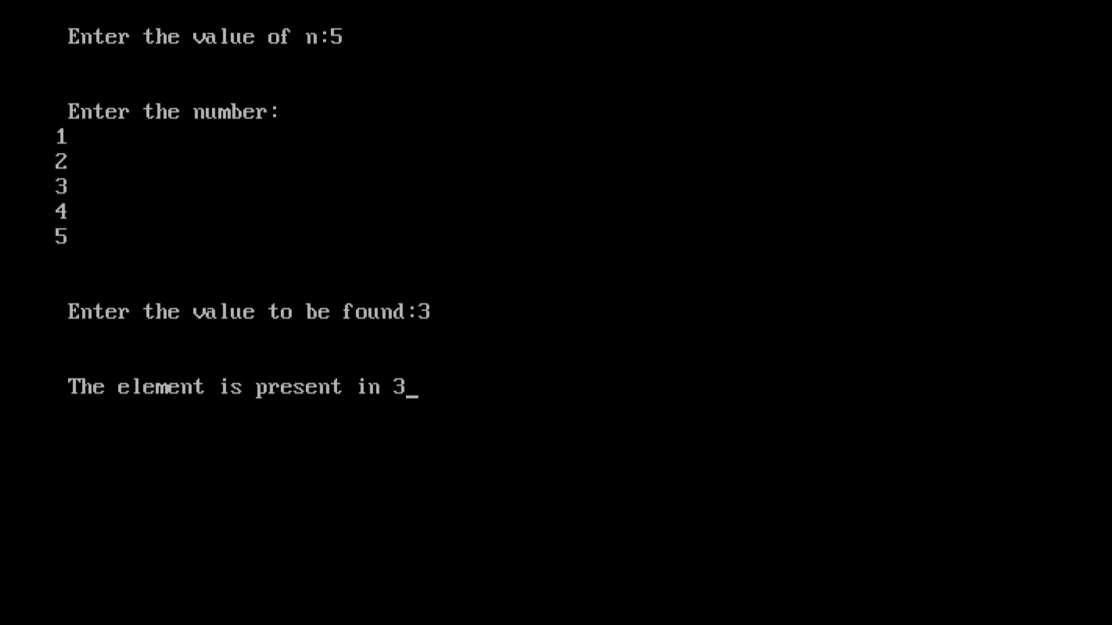
OUTPUT:

Result:
Thus the c program for sequential search is compiled and executed successfully.

EX.NO.1B BINARY SEARCH

Aim:
To create a c program to search the element in an array using Binary search algorithm.

Algorithm:

Step 1: Start the program.
Step 2: Declare the variables and an array of elements.
Step 3: Read the value of number of elements to be stored in the array.
Step 4: Read the values of the elements of the array.
Step 5: Divide the array of elements into two which gives a middle element.
Step 6: Get the element to be searched in the array.
Step 7: Compare the element with the middle element. If the element to be
searched is the middle element stop searching and print the position.
Step 8: If the element is lesser than the middle element the searching proceeds with
the first half of the array.
Step 9: If the element is greater than the middle element the searching proceeds
with the second half of the array.
Step 10: If the element is not present in the array print” Unsuccessful search”.
Step 11: If the element is present in the array, print the position of the searched
element.
Step 12: Stop the program.

#include<stdio.h>
#include<conio.h>
void main()
{
int a[30],k,x,l,m,h,n;
clrscr();
printf("enter the value of n:");
scanf("%d",&n);
printf("enter the elements:");
for(k=0;k<n;k++)
scanf("%d",&a[k]);
printf("enter the element to search:");
scanf("%d",&x);
l=0;h=n-1;
while(l<=h)
{
m=(l+h)/2;
if(x==a[m])
{
printf("\n\n successful search");
printf("\n\n the element is present at %d",m+1);
printf("\n the element is%d",x);
break;
}
if(x<a[m])
{
h=m-1;
continue;
}
if(x>a[m])
{
l=m+1;
continue;
}
}
while(l>h)
{
printf("unsuccesssful search");
break;

}
getch();
}

OUTPUT:
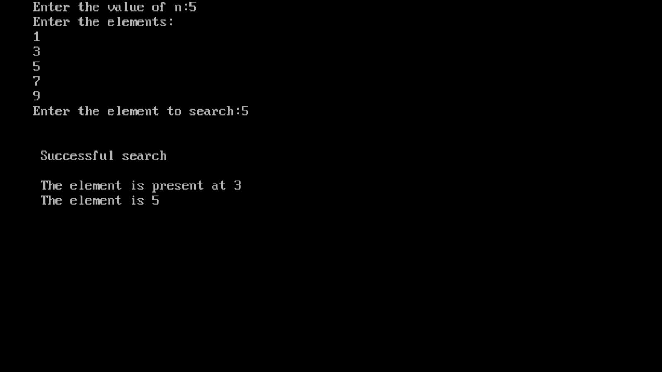

Result:

Thus the c program for binary search is compiled and executed successfully.
EX.NO. 2A) BUBBLE SORT
Aim:
To create a c program to sort the unsorted array using Bubble sort algorithm.

Algorithm:
Step 1: Start the program.
Step 2: Declare the variables and an array of elements.
Step 3: Read the value of number of elements to be stored in the array.
Step 4: Read the value of the elements of the array.
Step 5: Select the first element of the array and compare it with second element, if
the first element is greater than second, the positions are interchanged.
Step 6: Now, the first element is compared with third element if the first element
is lesser than the third element. The positions are interchanged.
Step 7: Repeat the process till the first element is compared with rest of the
elements in the array.
Step 8: Print the sorted list.
Step 9: Stop the program.
Program coding:
#include<stdio.h>
#include<conio.h>
void main()
{
int a[5],t,i,n,j;
clrscr();
printf("bubble sort");
printf("\n\nEnter the number of elements:");
scanf("%d",&n);
printf("Enter the value");
for(i=0;i<n;i++)
{
scanf("%d",&a[i]);
}
for(i=0;i<=n;i++)
{
for(j=i+1;j<n;j++)
{
if(a[i]>a[j])
{
t=a[i];
a[i]=a[j];
a[j]=t;
}
}
}
printf("\n The sorted list are");
for(i=0;i<n;i++)
{
printf("\n%d",a[i]);
}
getch();
}

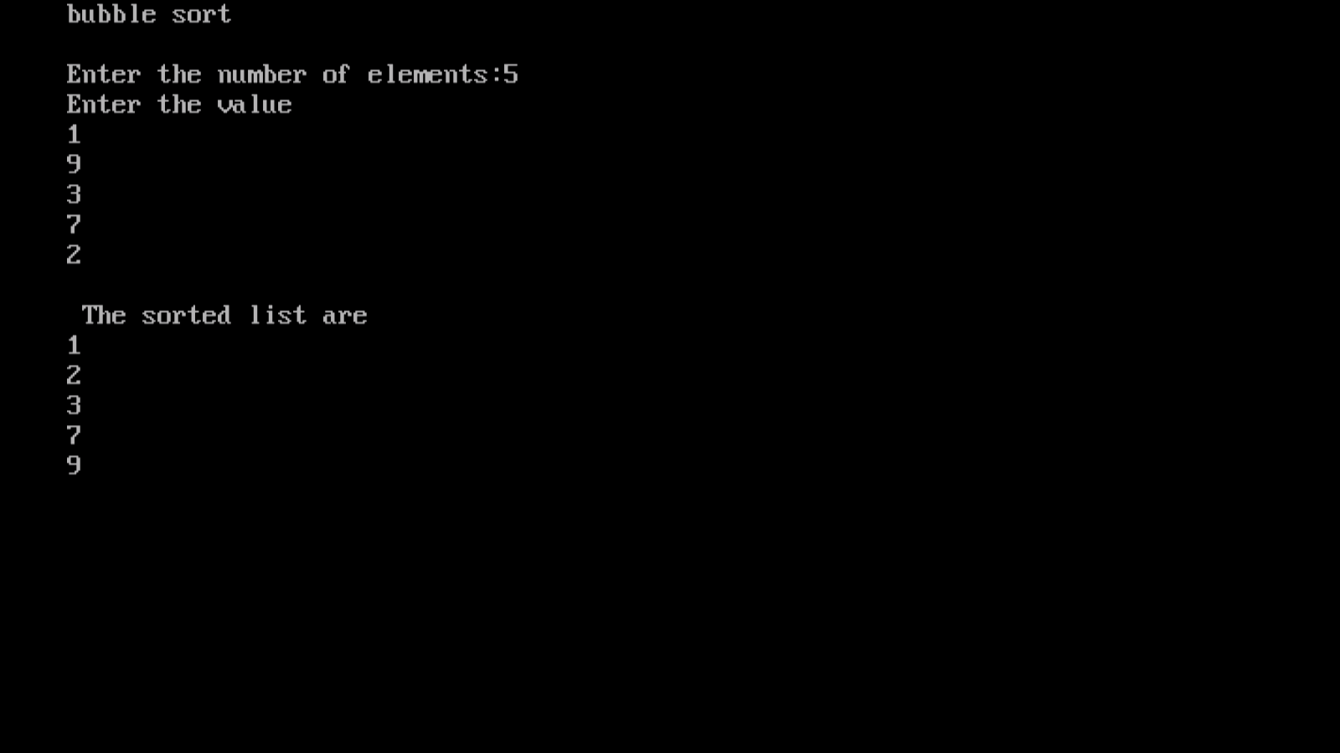
OUTPUT:

Result:
Thus the c program for bubble sorting is compiled and executed successfully.

EX.NO.2B SELECTION SORT
Aim:
To create a c program to sort the unsorted array using Selection sort algorithm.

Algorithm:
Step 1: Start the program.
Step 2: Declare the variables and an array of elements.
Step 3: Read the value of number of elements to be stored in the array.
Step 4: Read the values of the elements of the array.
Step 5: Select the first element from the array and then compare with the next
elements. If any element is found to be lesser interchange the elements.
Step 6: Select the next element and compare with the other elements, if any of
the elements is lesser than the selected element, exchange the positions.
Step 7: Repeat Step 5 and 6 until all the elements are sorted.
Step 8: Print the sorted list.
Step 9: Stop the program.
Program coding:

#include<stdio.h>
#include<conio.h>
void main()
{
int a[15],i,j,k,n,min;
clrscr();
printf("\t\t\t SELECTION SORT");
printf("\n enter the number of terms:");
scanf("%d",&n);
printf("\n enter the number to be sorted:");
for(i=0;i<n;i++)
{
scanf("\n%d",&a[i]);
}
for(i=0;i<n-1;i++)
{
k=i;
min=a[i];
for(j=i+1;j<n;j++)
{
if(a[j]<min)
{
min=a[j];
k=j;
}
}
a[k]=a[i];
a[i]=min;
}
printf("\n the sorted list is:\n");
for(i=0;i<n;i++)
{
printf("%d",a[i]);
printf("\t");
}
getch();
}

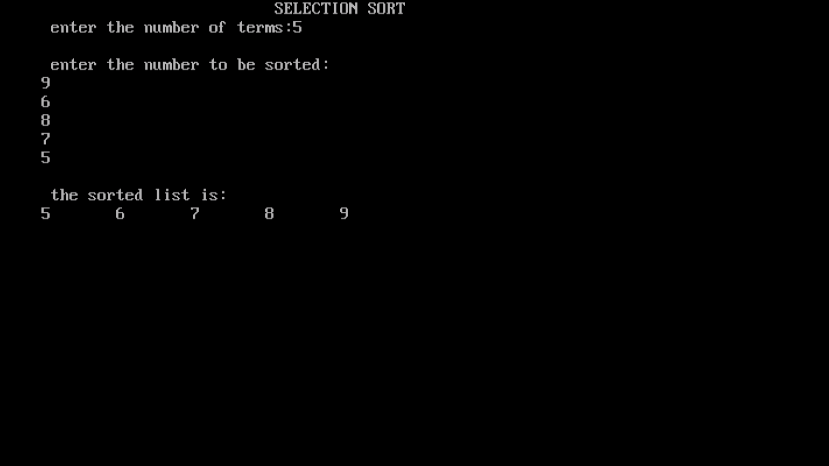
OUTPUT:

Result:

Thus the c program for selection sorting is compiled and executed successfully.

EX.NO.2C) INSERTION SORT
Aim:
To create a c program to sort the unsorted array using Insertion sort algorithm.

Algorithm:
Step 1: Start the program.
Step 2: Declare the variables and an array of elements.
Step 3: Read the value of number of elements to be stored in the array.
Step 4: Read the values of the elements of the array.
Step 5: The first iteration is to compare the first element with the second element.
The second iteration is to compare the first element with the third element
and goes on.
Step 6: While comparing, if it is found that any element can be inserted at suitable
position a space is created for it by shifting the other elements one position
up and inserts the desired element at suitable position.
Step 7: Finally sort the array.
Step 8: Stop the program.
Program coding:
#include<stdio.h>
#include<conio.h>
void main()
{
int i,j,k,n,save;
int a[30];
clrscr();
printf("Enter the no of elements to sort:");
scanf("%d",&n);
printf("Enter element:");
for(i=0;i<n;i++)
{
scanf("%d",&a[i]);
}
k=-1;
for(j=1;j<n;j++)
{
k=a[j];
i=j-1;
while(i>=0)
{
if(k<a[i])
{
a[i+1]=a[i];
save=i;
}
i--;
}
if(save!=-1)
a[save]=k;
}
printf("\n The sorted list is:");
for(i=0;i<n;i++)
{
printf("\n%d",a[i]);
}
getch();
OUTPUT:

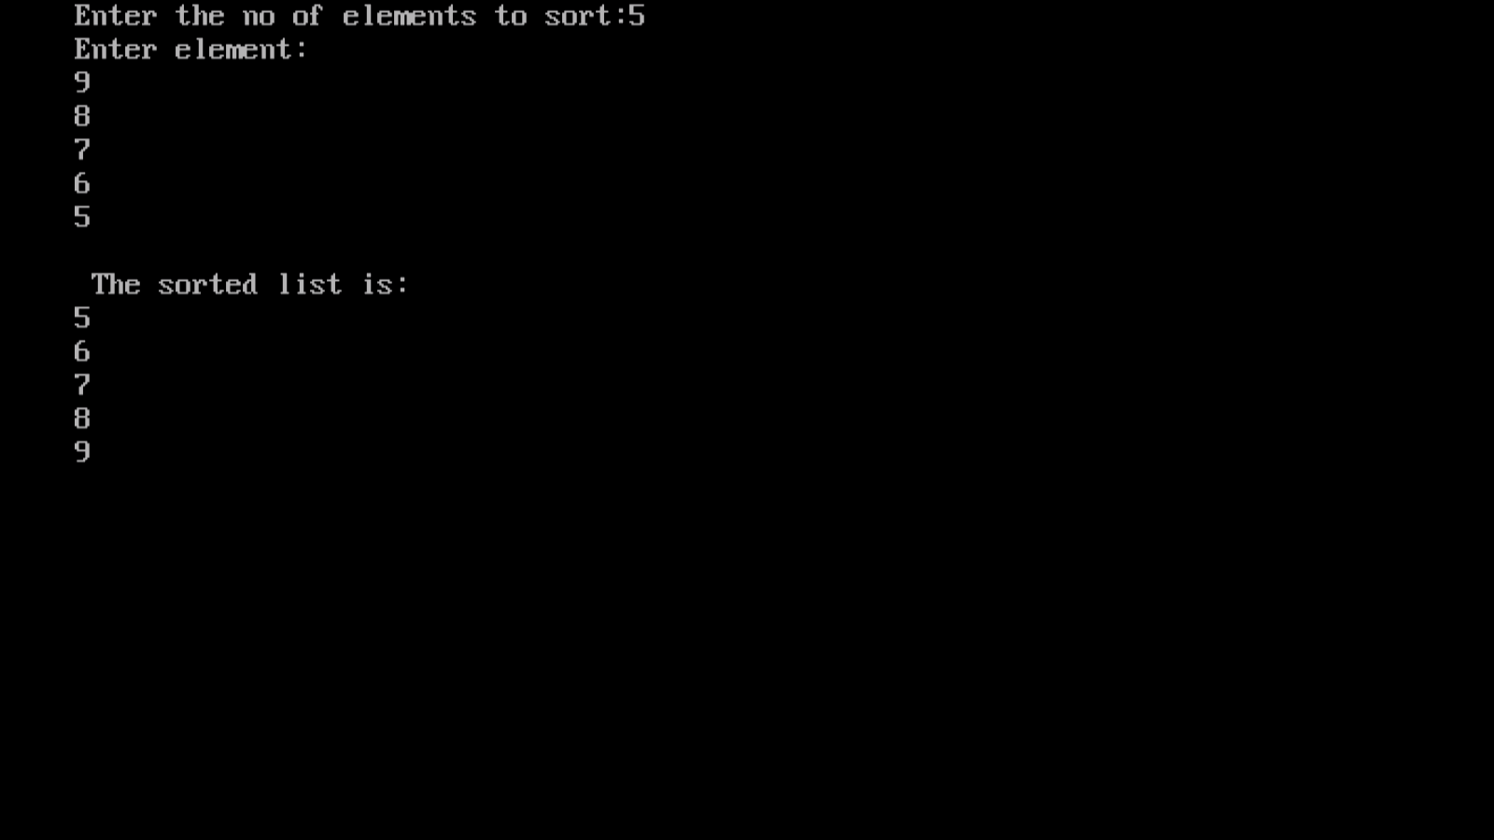

Result:

Thus the c program for insertion sorting is compiled and executed successfully.

EX.NO.3A) SHELL SORT
Aim:
To create a c program to sort the unsorted array using Shell sort algorithm.

Algorithm:
Step 1: Start the program.
Step 2: Declare the variables and an array of elements.
Step 3: Read the value of number of elements to be stored in the array.
Step 4: Read the values of the elements of the array.
Step 5: In the first iteration, the element are divided with a gap say (S, 3) etc.
Step 6: The sub list obtained after the division is sorted by comparing the elements
swapping it.
Atep7: Repeat Step 5 for the next iteration.
Step 8: The sorted sub lists are recombined.
Step 9: Print the sorted array of elements.
Step 10: Stop the program.
PROGRAM CODING:
#include<stdio.h>
#include<conio.h>
void shell(int a[],int n);
int i,j,k,n,t,a[25];
void main()
{
clrscr();
printf("\nEnter the number to be sorted");
scanf("\n%d",&n);
printf("\nEnter the element to be sorted");
for(i=0;i<n;i++)
{
scanf("%d",&a[i]);
}
shell(a,n);
printf("\nThe sorted list are");
for(i=0;i<n;i++)
{
printf("\n%d",a[i]);
}
getch();
}
void shell(int a[],int n)
{
for(i=(n+1)/2;i<=1;i/=2);
{
for(j=1;j<=n-1;j++)
{
t=a[j];
k=j-1;
while(k>=0&&t<a[k])
{
a[k+1]=a[k];
k=k-1;
}
a[k+1]=t;
}
}
}

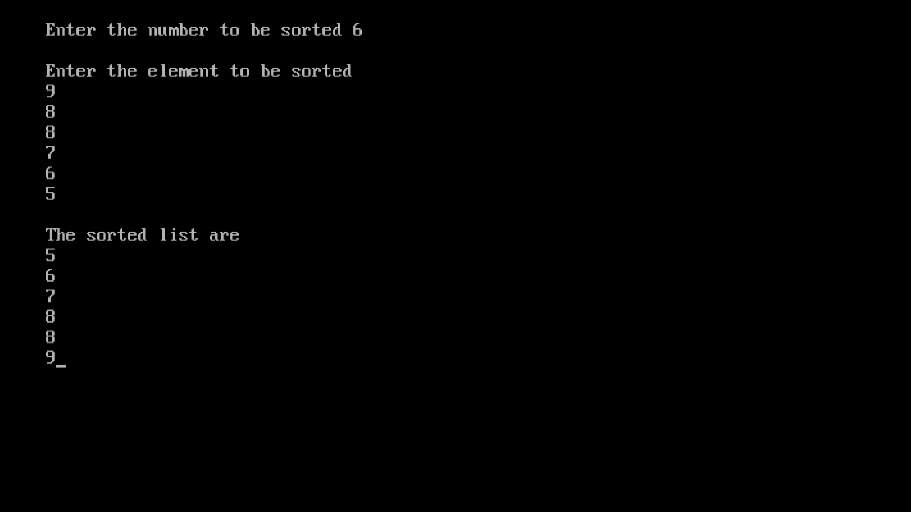
OUTPUT:

Result:

Thus the c program for shell sorting is compiled and executed successfully.

EX.NO.3B) QUICK SORT
Aim:
To create a c program to sort the unsorted array using Quick sort algorithm.

Algorithm:

Step 1: Start the program.
Step 2: Declare the variables and an array of elements.
Step 3: Read the value of number of elements to be stored in the array.
Step 4: Read the values of the elements of the array.
Step 5: Select the first element and the last element called pivot from the array and
compare with the other elements from the both sides of the array.
Step 6: The elements which are lesser than the pivot element is placed before the
pivot element and greater placed after the pivot element.
Sterp7: Then the array is divided into two. Step 5 and Step 6 is repeated on both
the halves of the array until the sorting is done completely.
Step 8: Print the sorted array.
Step 9: Stop the program.

PROGRAM CODING:

#include<stdio.h>
#include<conio.h>
void quick(int a[],int,int);
void split(int a[],int,int);
void main()
{
int i,n,a[20];
clrscr();
printf("\n Enter the limit:");
scanf("%d",&n);
printf("\n Enter the elements to be sorted\n");
for(i=0;i<n;i++)
{
printf("\n\t a[%d]=",i);
scanf("%d",&a[i]);
}
quick(a,0,n-1);
printf("\n The sorted elements are:");
for(i=0;i<n;i++)
printf("%d\t",a[i]);
getch();
}
void quick(int a[],int first,int last)
{
int x,i,j;
if(first<last)
{
x=a[first];
i=first;
j=last;
while(i<j)
{
while(a[i]<=x&&i<last)
i++;
while(a[j]>=x&&j>first)
j--;
if(i<j)
split(a,i,j);
}
split(a,first,j);
quick(a,first,j-1);
quick(a,j+1,last);
}
}
void split(int a[],int i,int j)
{
int temp;
temp=a[i];
a[i]=a[j];
a[j]=temp;
}

OUTPUT:
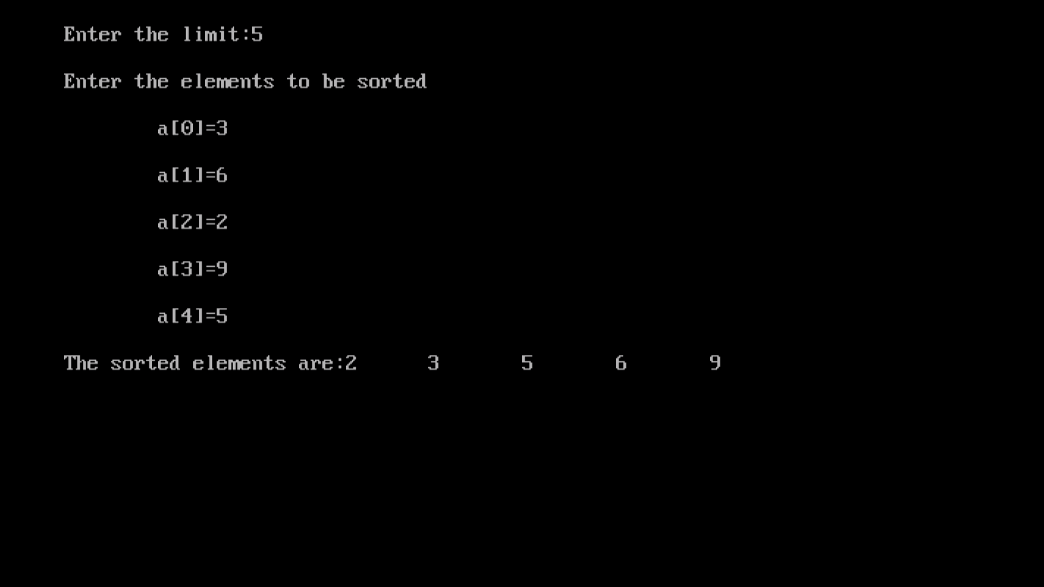

Result:

Thus the c program for quick sorting is compiled and executed successfully.
EX.NO.3C) HEAP SORT
Aim:
To create a c program to sort the unsorted array using Heap sort algorithm.

Algorithm:
Step 1: Start the program.
Step 2: Declare the variables and an array of elements.
Step 3: Read the value of number of elements to be stored in the array.
Step 4: Read the value of the elements of the array.
Step 5: Create the heap (tree) with the given set of elements.
Step 6: Compare the root element with the last element of the heap.
Step 7: If the last element is greater than the root element, swapping is done and
rearrange the elements to get balanced.
Step 8: Repeat the Step 6 and Step 7 until all the elements are sorted.
Step 9: Print the sorted array of elements
Step 10: Stop the program.

PROGRAM CODING:

#include<stdio.h>
#include<conio.h>
void heapsort(int k[],int n);
void createheap(int k[],int n);
void main()
{
int k[25],i,n;
clrscr();
printf("Enter the limit:");
scanf("%d",&n);
printf("Enter the elements to be sorted:");
for(i=1;i<=n;i++)
scanf("%d",&k[i]);
heapsort(k,n);
getch();
}
void heapsort(int k[],int n)
{
int q,key,i,j,temp;
createheap(k,n);
for(q=n;q>=2;q--)
{
temp=k[1];
k[1]=k[q];
k[q]=temp;
i=1;
key=k[i];
j=1;
if((j+1)<q)
{
if(k[j+1]>k[j])
j++;
while((j<=q-1)&&(k[j]>key))
{
temp=k[i];
k[i]=k[j];
k[j]=temp;
i=j;
j=2*i;
if((j+1)<q)
{
if(k[j+1]>k[j])
j=j+1;
if(j>n)
{
j=n;
k[i]=key;
}
}
}
}
}
printf("\n\n The elemets after sorting:\n");
for(i=1;i<=n;i++)
printf("\t%d",k[i]);
}
void createheap(int k[],int n)
{
int i,j,q,key,temp;
for(q=2;q<=n;q++)
{
i=q;
key=k[q];
j=i/2;
while((i>1)&&(key>k[j]))
{
temp=k[i];
k[i]=k[j];
k[j]=temp;
i=j;
j=i/2;
if(j<1)
j=1;
k[i]=key;
}
}
printf("\n\n Heap generated for the elements as follows:\n");
for(q=1;q<=n;q++)
printf("\t%d",k[q]);
}

OUTPUT:
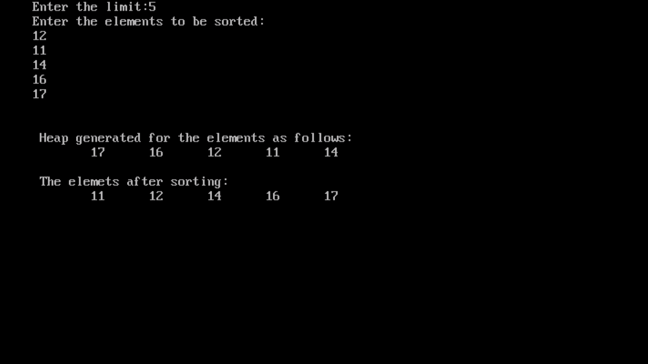

Result:

Thus the c program for heap sorting is compiled and executed successfully.

EX.NO.4A) MERGE SORT
Aim:
To create a c program to sort the unsorted array using Merge sort algorithm.

Algorithm:
Step 1: Start the program.
Step 2: Declare the variables and two arrays of elements.
Step 3: Read the value of number of elements to be stored in the two arrays.
Step 4: Read the values of the elements of two arrays.
Step 5: Compare the first element with the last element, if the first is lesser than the
last element compute the middle value sort and split the array as first,
middle, middle+1,and the last.

Step 6: Compare two arrays, If the 0th element of the first array (a[i]) is smaller
than the 0th element of the second (b[i]) array then put the 0th element of the
first array in the third array to be merged.
Step 7: Then compare the 1st element of a[i] with the 0th element of b[i] and repeat
the steps.
Step 8: Print the sorted third array.
Step 9: Stop the program.
PROGRAM CODING:

#include<stdio.h>
#include<conio.h>
void main()
{
int i,n,j,k,min,a[10];
clrscr();
printf("MERGE SORT");
printf("\nEnter the limit");
scanf("\n\n%d",&n);
printf("enter the element");
for(i=0;i<n;i++)
{
scanf("%d",&a[i]);
}
for(i=0;i<n;i++)
{
k=i;
min=a[i];
for(j=i+1;j<n;j++)
{
if(a[j]<min)
{
min=a[j];
k=j;
}
}
a[k]=a[i];
a[i]=min;
}
printf("The sorted list are\n");
for(i=0;i<n;i++)
{
printf("%d\n\n",a[i]);
}
getch();
}

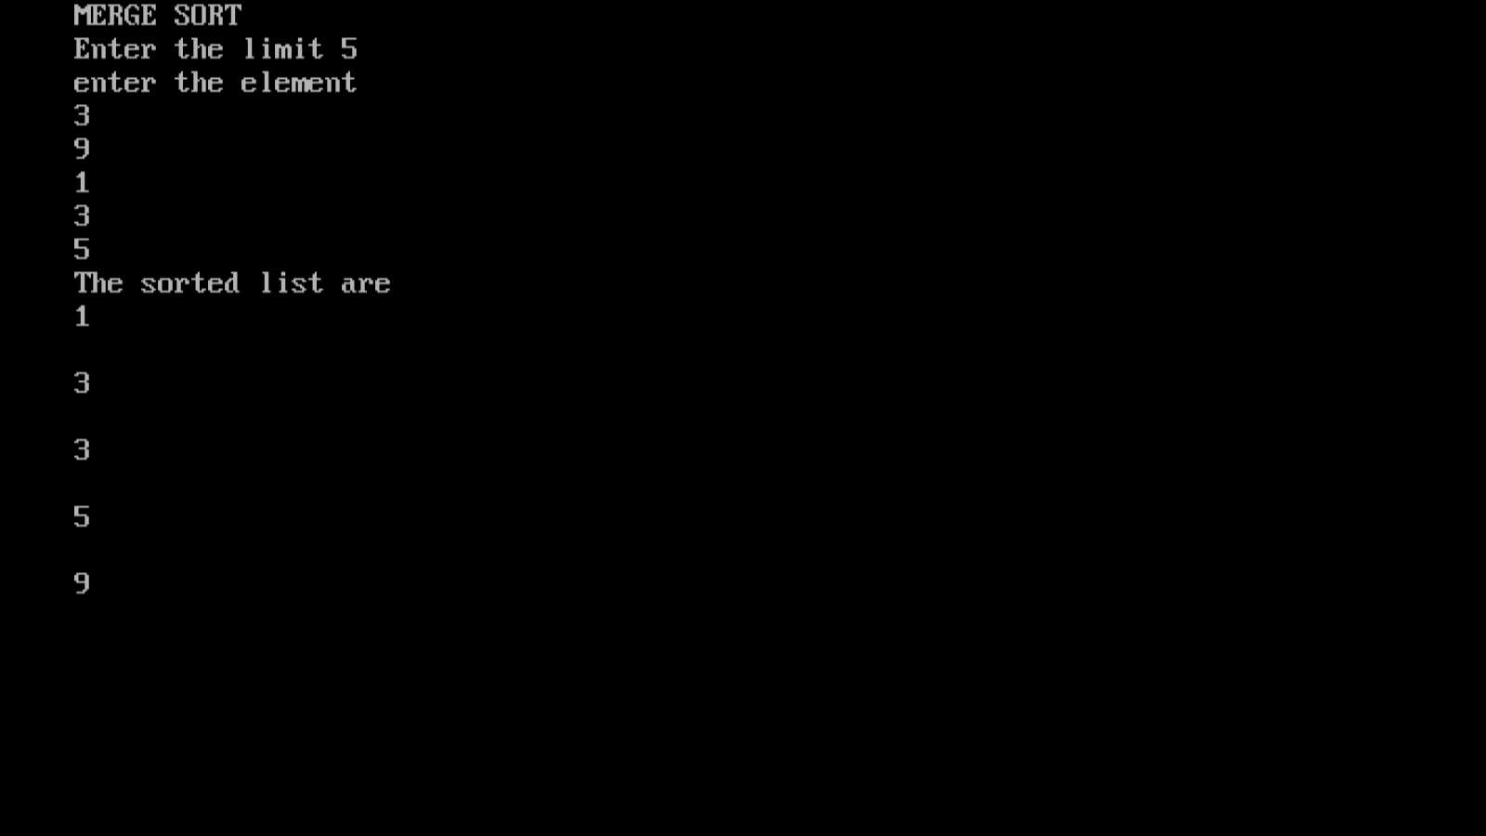
OUTPUT:
Result:

Thus the c program for merge sorting is compiled and executed successfully.
EX.NO.4B RADIX SORT
Aim:
To implement Radix mSort Using Data Structures.

Algorithm:

- Start the program.

- Get the values.

- Values of the Actual Digits in the positional representations of the numbers being sorted.

- Start at the most-significant digit and advance through the least-significant digits as long as the corresponding digits in the two numbers match.

- Using decimal base , the numbers can be partitioned into ten groups based on their most significant digit.

vi) Each number in the order in which it appears in the file and place it into one of ten
queues.

- Restore each queue to the original file starting with the queue of numbers with a 0 digit and ending with the queue of numbers with a 9 digit.
- Stop the program.
Program
#include<stdio.h>
#include<conio.h>
radix_sort(int array[], int n);
void main()
{
int array[100],n,i;
clrscr();
printf("Enter the number of elements to be sorted:
");
scanf("%d",&n);
printf("\n Enter the elements to be sorted: \n");
for(i =0;i<n;i++ )
{
printf("\tArray[%d] = ",i);
scanf("%d",&array[i]);
}
printf("\n Array Before Radix Sort:"); //Array
Before Radix Sort
for(i =0;i<n;i++)
{
printf("%8d", array[i]);
}
printf("\n");
radix_sort(array,n);
printf("\n Array After Radix Sort: "); //Array
After Radix Sort
for(i =0;i<n;i++)
{
printf("%8d", array[i]);
}
printf("\n");
getch();
}
radix_sort(int arr[], int n)
{
int bucket[10][5],buck[10],b[10];
int i,j,k,l,num,div,large,passes;
div=1;
num=0;
large=arr[0];
for(i=0; i<n; i++)
{
if(arr[i] > large)
{
large = arr[i];
}
while(large > 0)
{
num++;
large = large/10;
}
for(passes=0; passes<num; passes++)
{
for(k=0;k<10;k++)
{
buck[k] = 0;
}
for(i=0;i<n;i++)
{
l = ((arr[i]/div)%10);
bucket[l][buck[l]++] = arr[i];
}
i=0;
for(k=0;k<10;k++)
{
for(j=0;j<buck[k];j++)
{
arr[i++] = bucket[k][j];
}
}
div*=10;
}
}
}
Sample output
Enter the number of elements to be sorted: 7
Enter the elements to be sorted:
Array[0]=777
Array[1]=269
Array[2]=158
Array[3]=341
Array[4]=265
Array[5]=989
Array[6]=506
Array before radix sort: 777 269 158 341 265 989
506
Array after radix sort: 158 265 269 341 506 777
989

Result:

Thus the program was successfully executed and the output was verified.

EX.NO.5 SPARSE MATRIX REPRESENTATION AND FIND ITS TRANSPOSE

AIM

To write a C program to represent sparse matrix and to find its transpose

DESCRIPTION

An array is called sparse if it has a relatively number of zero elements. In the following example out of 36 elements only 8 are non zero. This is sparse array.
Col6
15 0 0 22 0 -15
0 11 3 0 0 0
0 0 0 -6 0 0
0 0 0 0 0 0
91 0 0 0 0 0
row 6 0 0 28 0 0 0

if we store those array in memory, there would be much wasted space. To avoid this, space array can be represented by
- Vector representation
- Linked representation

ALGORITHM

REPRESENTATION

Step1. Start the program

Step 2: read the size of matrices A – m,n
Step 3: read the elements of matrix A
Step 4: select the choice for you want. If you select case 1 then call the sparse matrix representation. Else goto Step 7.
Step 5: print representation sparse matrix
Step 6: if you select case 2 then goto transpose function
Step 7: perform the transpose of sparce matrices
Step 8: Print the resultant matrix
Step 9: Stop

TRANSPOSE (A,B)
//A is matrix represented in sparse form //
//B is set to be its transpose //
- (m ,n ,t) ← ( A (0,1) , A (0,2) , A (0,3) )
- ( B (0,1), B(0,2) , B(0,3) ) ← (n, m, t)
- if t <= 0 then return //check for zero matrix//
- q → 1 // q is position of next term in B//
- for col → 1 to n do //transpose by columns//
- for p → 1 to t do //for all non zero terms do//
- if A(p,2) = col //correct column//
- then [ ( B (q,1) , B (q,2) , B (q,3) ) → ( A (p,2) , A (p,1) , A (p,3) )
- q → q+1 //insert next term of B//
- end
- end
end TRANSPOSE

PROGRAM CODING:

#include<stdio.h>
#include<conio.h>
void main()
{
int a[10][10],b[10][10];
int m,n,p,q,t,col;
int i,j;
clrscr();
printf("Enter the no of row and column:\n");
scanf("%d%d",&m,&n);
for(i=1;i<=m;i++)
{
for(j=1;j<=n;j++)
{
printf("a[%d][%d]=",i,j);
scanf("%d",&a[i][j]);
}
}
printf("\n\n");
printf("\n\n The matrix is:\n\n");
for(i=1;i<=m;i++)
{
for(j=1;j<=n;j++)
{
printf("%d",a[i][j]);
}
printf("\n");
}
t=0;
printf("\n\n The non zero value matrix are:\n\n");
for(i=1;i<=m;i++)
{
for(j=1;j<=n;j++)
{
if(a[i][j]!=0);
{
t=t+1;
b[t][1]=i;
b[t][2]=j;
b[t][3]=a[i][j];
}
}
}
printf("\n");
printf("a[0%d%d%d]\n",m,n,t);
for(i=1;i<=t;i++)
{
printf("a[%d%d%d%d]\n",i,b[i][1],b[i][2],b[i][3]);
}
b[0][1]=n;
b[0][2]=m;
b[0][3]=t;
q=1;
printf("\n\n The tranpose of the matrix:\n");
if(t>0)
{
for(i=1;i<=n;i++)
{
for(j=1;j<=t;j++)
{
if(b[j][2]==i)
{
a[q][1]=b[j][2];
a[q][2]=b[j][1];
a[q][3]=b[j][3];
q=q+1;
}
}
}
}
printf("\n\n");
printf("a[%d%d%d]\n",b[0][1],b[0][2],b[0][3]);
for(i=1;i<=t;i++)
{
printf("a[%d%d%d%d]\n",i,a[i][1],a[i][2],a[i][3]);
}
getch();
}

OUTPUT:

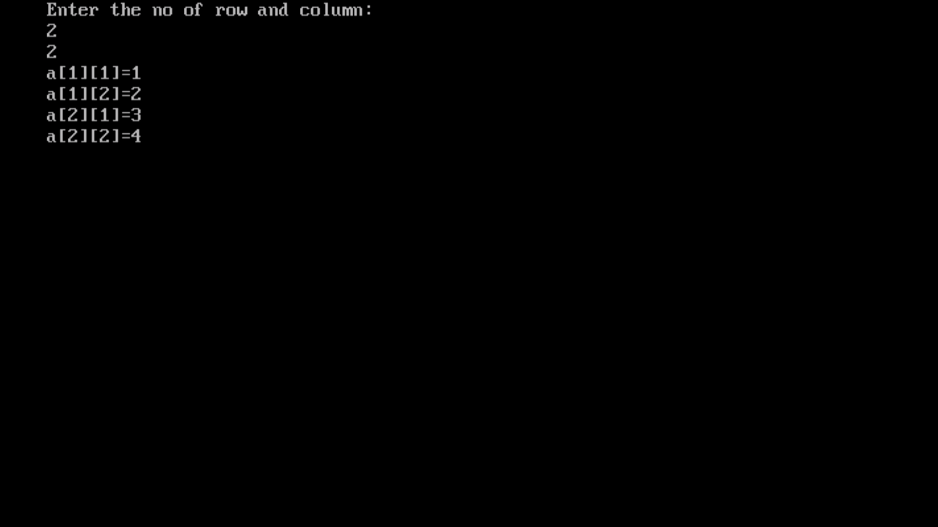
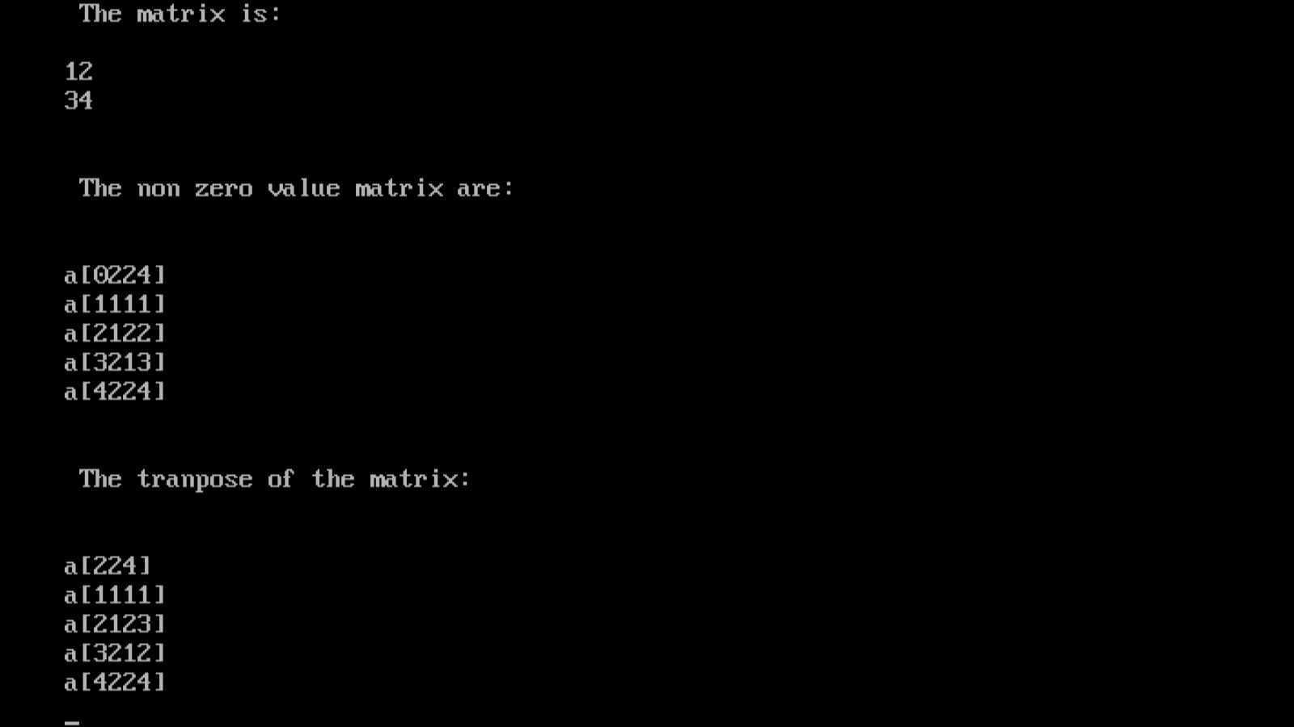

Result:

Thus the program was successfully executed and the output was verified.

CYCLE-2
EX.NO.6 IMPLEMENTATION OF STACK USING ARRAY

Aim
To write a C program to perform the implementation of stack using array.

Algorithm:

Step 1: Start the program

Step 2: Initialize the array variable st[100] for storing elements and declare the required variables.

Step 3: Define a function to push , pop and display the data item of the queue.

Step 4: For push() function
Get the new elements
Create the top is greater than array size,
display “stack is overflow”.
else
Insert the new element and increment the top
pointer.

Step 5: For pop() function
If the Stack is empty then display “stack is
underflow”.
else
Decrement the top pointer.

Step 6: For display() function
Apply the loop for to display the stack elements.

Step 7: Stop the program.
PROGRAM CODING:

#include<stdio.h>
#include<conio.h>
#include<stdlib.h>
void main()
{
int choice,n,a[30],top=0,i;
clrscr();
printf("\n Stack using array");
do
{
printf("\n Main menu");
printf("\n1.stack max");
printf("\n2.push");
printf("\n3.pop");
printf("\n4.display");
printf("\n5.size");
printf("\n6.exit");
printf("\n Enter your choice:");
scanf("%d",&choice);
switch(choice)
{
case 1:
printf("\n Enter the stack max size:");
scanf("%d",&n);
break;
case 2:
if(top>=n)
{
printf(" The stack is full");
}
else
{
printf("\n Enter the element:");
top++;
scanf("%d",&a[top]);
}
break;
case 3:
if(top==0)

{
printf("\n The stack is empty");
}
else
{
printf("\n Poped out element is %d \n",a[top]);
top --;
}
break;
case 4:
if(top!=0)
{
printf("\n Stack contains \n");
for(i=1;i<=top;i++)
printf("\t %d",a[i]);
}
else
{
printf("\n Stack is empty");
}
break;
case 5:
printf("\n The size of stack is %d",top);
break;
default:
exit(1);
}
}while(choice<6);
getch();
}
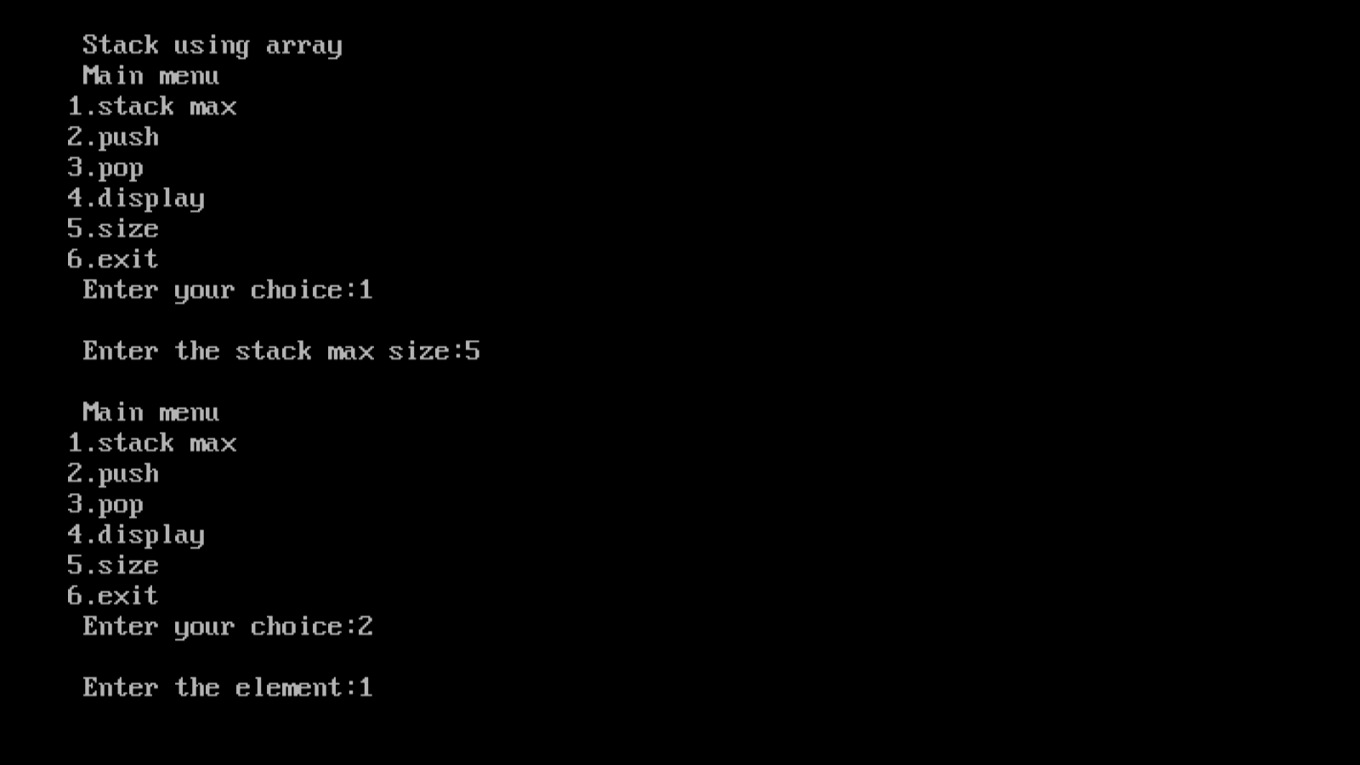
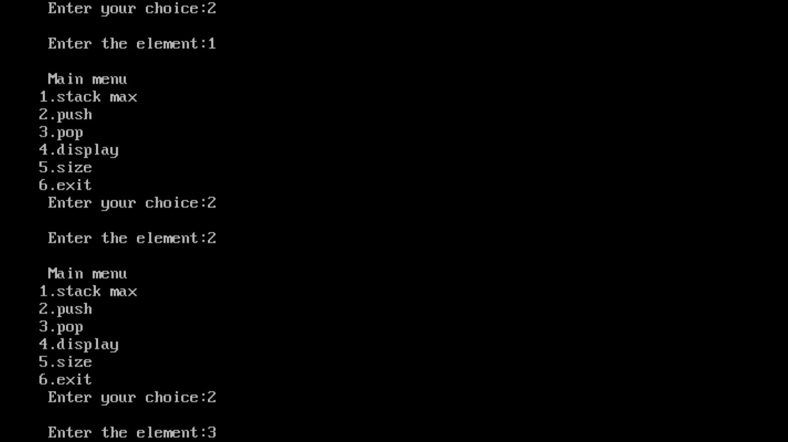
OUTPUT
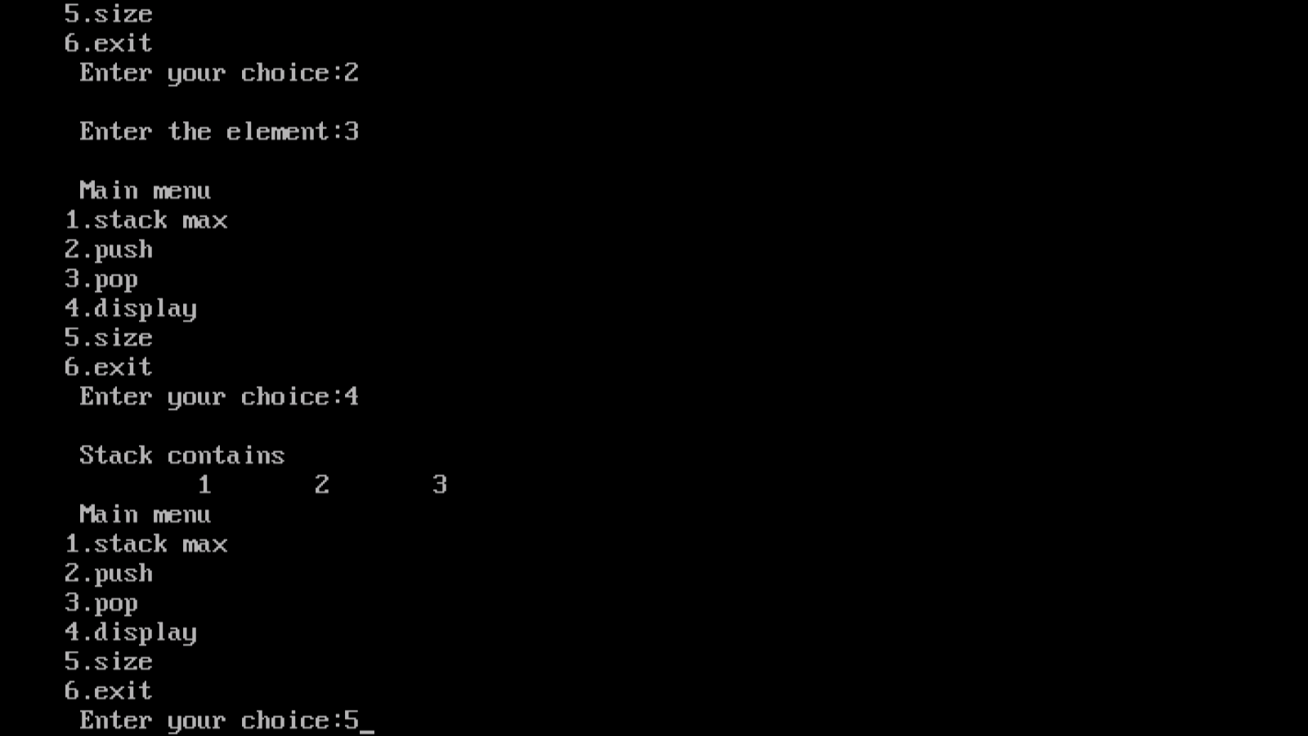
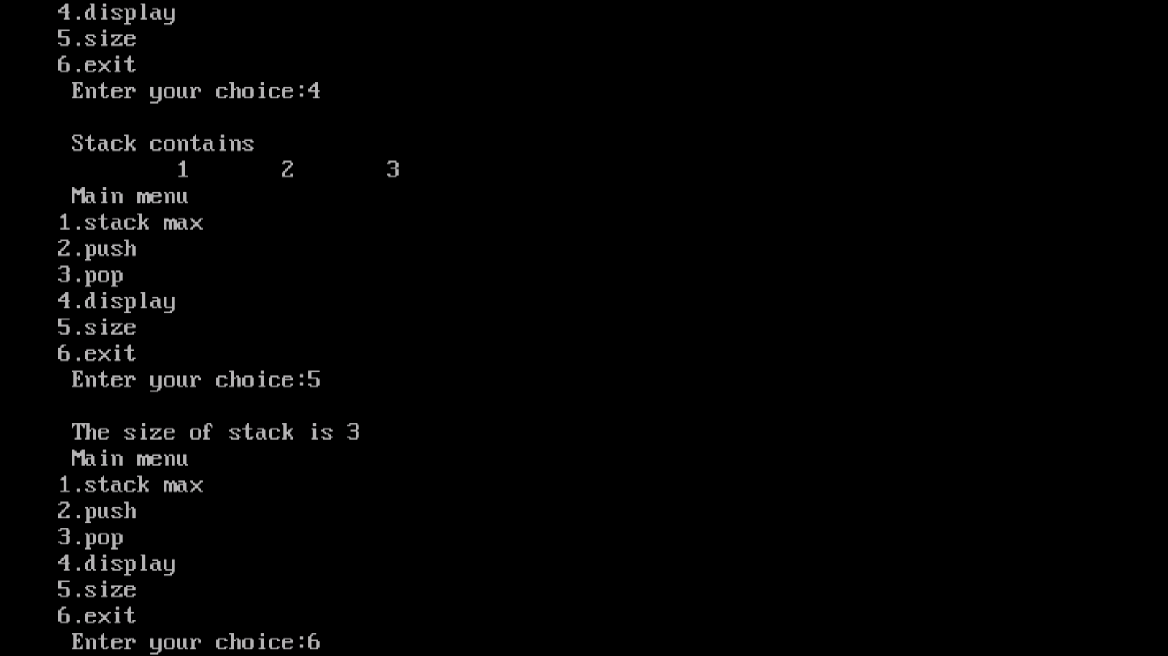

Result:

Thus the program was successfully executed and the output was verified.

EX.NO.7)CONVERSION OF INFIX EXPRESSION TO POSTFIX EXPRESSION

AIM

To write a C Program that uses the stack operation to perform the following
- converting infix expression into postfix expression
- evaluating the postfix expression
ALGORITHM:
Step 1. start
Step 2. first initialize the stack to be empty
Step 3. for each character in the input string
If input string is an operand, append to the output
if the input string is a left paranthesis , push it onto the stack
else
if stack is empty or the operator has higher priority than the operator on
the topof stack or
the top of the stack is opening parenthesis
then
push the operator onto the stack
else
pop the operator from the stack and append to the output
Step 4. if the input string is a closing parenthesis , pop operators from the stack
and append the operators
to the output until an opening parenthesis is encountered. Pop the
opening parenthesis from the stack
and discard it.
Step 5. if the end of the input string is encountered , then iterate the loop until the
stack is not empty. Pop
the stack and append the remaining input string to the output.
Step 6. stop

PROGRAM
#include<stdio.h>
#include<ctype.h>
#include<string.h>
static char str[20];
int top=-1;
main()
{
char in[20],post[20],ch;
int i,j,l;
clrscr();
printf("enter the string");
gets(in);
l=strlen(in);
for(i=0,j=0;i<l;i++)
if(isalpha(in[i]))
post[j++]=in[i];
else
{
if(in[i]=='(')
push(in[i]);
else if(in[i]==')')
while((ch=pop())!='(')
post[j++]=ch;
else
{
while(priority(in[i])<=priority(str[top]))
post[j++]=pop();
push(in[i]);
}
}
while(top!=-1)
post[j++]=pop();
post[j]='\0';
printf("\n equivalent infix to postfix is:%s",post);
getch();
}
priority (char c)
{
switch(c)
{
case'+':
case'-': return 1;
case'*':
case'/':
return 2;
case'$': return 3;
}
return 0;
}
push(char c)
{
str[++top]=c;
}
pop()
{
return(str[top--]);
}

SAMPLE INPUT AND OUTPUT

enter the string(a+b)-(c-d)*e/f

equivalent infix to postfix is:ab+cd-e*f/-

enter the stringa+b/c*d

equivalent infix to postfix is:abc/d*+

Result:

Thus the program was successfully executed and the output was verified.

ii)ALGORITHM

Step 1: Start

Step 2: Assign top=-1

Step 3: Read the input expression

Step 4: for i=0;s[i]!=’\0’ in steps of 1

Step 5: If isdigit(ch)

Step 5.1:Push(ch)

Step 6: otherwise

Step 6.1:op1=pop()

Step 6.2: op2=pop()

Step 7: c=op2+op1

Step 8: Push(c)

Step 9: c=op2-op1

Step 10: Push(c)

Step 11: c=pow(op2,op1)

Step 12: Push(c)

Step 13: c=op2/op1

Step 14:Push(c)

Step 15: Print the result

Step 16:Push(int x)

Step 17:Increment top by 1

Step 18: s1.item(s1.top3)=x

Step 19:pop()

Step 20: Read x

Step 21: x1=s1.item[s1.top]

Step 22:s1.top—

Step 23:return x

Step 24: Stop

PROGRAM CODING:
#include<stdio.h>
#include<conio.h>
#include<math.h>
void main()
{
char expr[100];
int expr_ind=0;
int stack[100];
int top=-1;
int a=0,b=0;
clrscr();
printf("\n Enter the expression:");
scanf("%s",expr);
while(expr[expr_ind]!='\0')
{
if(expr[expr_ind]>='0'&&expr[expr_ind]<='9')
{
top++;
stack[top]=expr[expr_ind]-'0';
}
else
{
a=stack[top--];
b=stack[top];
switch(expr[expr_ind])
{
case'+':stack[top]=a+b;break;
case'-':stack[top]=a-b;break;
case'*':stack[top]=a*b;break;
case'%':stack[top]=a%b;break;
}
}
expr_ind++;
}
printf("\n The value of expression is %d",stack[top]);
getch();
}

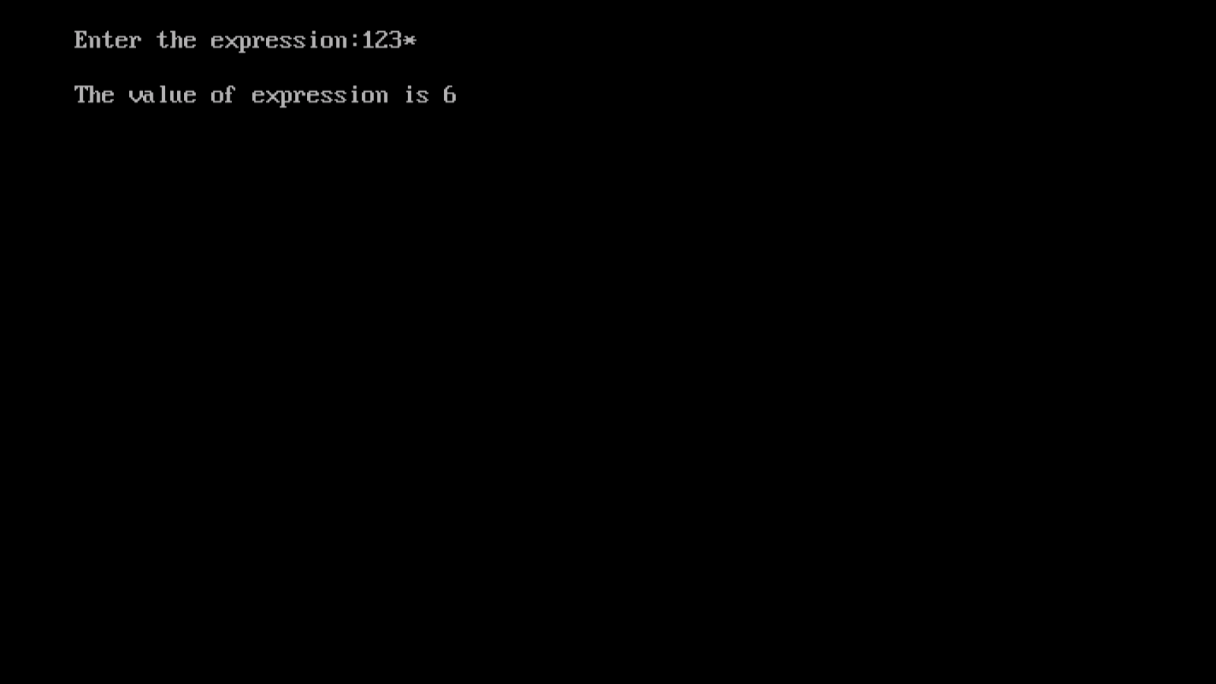
OUTPUT:

Result:

Thus the program was successfully executed and the output was verified.

EX.NO.8 QUEUE USING ARRAY

AIM

To write a C program to perform queue operation using array

ALGORITHM
FUNCTION QINSERET (Q, F, R, N, Y)
Step 1: [overflow]
If R>=N
Then printf(“ overflow”)
Return
Step 2: [Increment rear pointer]
R<-R+1
Step 3: [ Insert element]
Q[R]<-y
Step 4: [Is front pointer properly set?]
If F=0
Then f<-1
Return
FUNCTION QDELETE (Q, F, R)
Step 1: [Underflow]
If F=0
Then printf(“Queue underflow”)
Return (0)
Step 2: [Delete element]
y<-q[f]
Step 3: [Is Queue Empty?]
If F=R
Then F=R=0
Else
F=F+1
Step 4:[Return element]
Return(r)

PROGRAM CODING:

#include<stdio.h>
#include<conio.h>
#include<stdlib.h>
void main()
{
int ch,n,queue[50],rear=0,front=0,i,item;
clrscr();
printf("\n Implementation of queue using array");
do
{
printf("\n Main menu");
printf("\n1.queue max");
printf("\n2.add");
printf("\n3.delete");
printf("\n4.display");
printf("\n5.queue size");
printf("\n6.exit");
printf("\n Enter your choice");
scanf("%d",&ch);
switch(ch)
{
case 1:
{
printf("\n Enter the queue size");
scanf("%d",&n);
break;
}
case 2:
{
if((front==n)||(rear>n))
printf("\n The queue is full");
else
{
printf("\n Enter the element");
scanf("%d",&item);
rear=rear+1;
queue[rear]=item;
printf("\n The element is added");
}
break;
}
case 3:
{
if(rear==front)
{
printf("\n The queue is empty");
}
else
{
front=front+1;
item=queue[front];
printf("\n The deleted element is %d",item);
}
break;
}
case 4:
{
if(rear==front)
printf("\n The queue contains");
for(i=front+1;i<=rear;i++);
{
printf("\t %d",queue[i]);
}
break;
}
case 5:
{
if(rear==front)
printf("\n The queue is empty");
else
printf("\n The size of queue is %d",(rear-front));
}
case 6:
{
exit(1);
}
}
}while(ch<7);
getch();

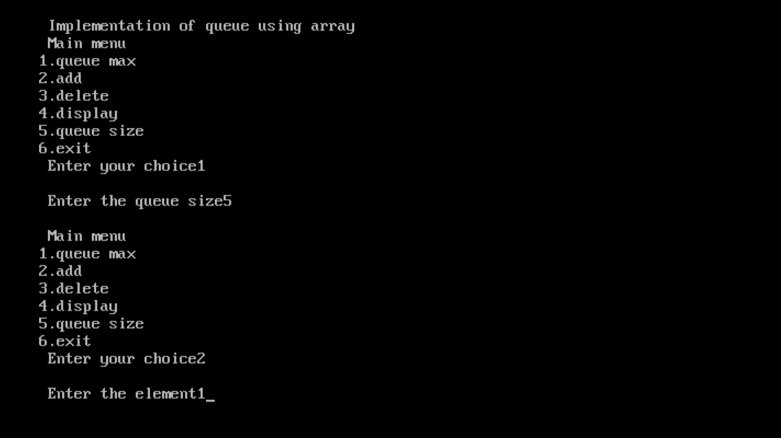
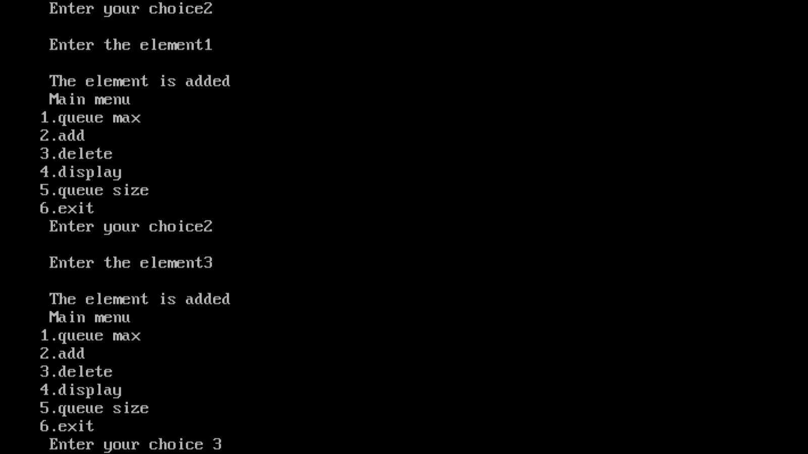
OUTPUT:

Result:

Thus the program was successfully executed and the output was verified.

EX.NO.9 CIRCULAR QUEUE

AIM

To write a c program to perform circular queue operation

DESCRIPTION

ALGORITHM

Step 1. Start the program

INSERTION

Step 2: Advance rear clock wise
Rear <- rear+1 mod n
Step 3: if front=rear then
Call (queue-full)
Step 4: insertion of new item
Q (rear)<- item
Step 5: return (0)

DELETION

Step 6: if front=rear then
Call (queue_empty)
Step 7: advance front clock wise
Front<-front+1 mod n
Step 8: item<-Q(front)
Step 9: return(0)

VIEW

Step 10: if front and rear=-1
Call queue is empty
Step 11: return
Step 12: print[queue[F]]
Step 13:if[((rear+1)mod q size)++front)]
Then print queue is full
Step 14: return(0)

PROGRAM CODING:
#include<stdio.h>
#include<conio.h>
#define max 5
int front,rear,q[max];
void enqueue();
void dequeue();
void qdisplay();
void main()
{
int c;
clrscr();
front=rear=-1;
do
{
printf("\n choose:- 1.Enqueue\t2.Dequeue\t3.Display\t4.Exit\nEnter your choice:");
scanf("%d",&c);
switch(c)
{
case 1:enqueue();break;
case 2:dequeue();break;
case 3:qdisplay();break;
case 4:printf("\n End");break;
default:printf("\n Wrong choice");break;
}
}while(c!=4);
getch();
}
void enqueue()
{
int x;
if((front==0&&rear==max-1)||(front==rear+1))
{
printf("\n Queue overflow");
}
if(front==-1)
{
front=rear=0;
}
else

{
if(rear==max-1)
{
rear=0;
}
else
{
rear++;
}
}
printf("\n Enter the number:");
scanf("%d",&x);
q[rear]=x;
}
void dequeue()
{
int y;
if(front==-1)
{
printf("\n Q is underflow");
}
y=q[front];
if(front==rear)
{
front=rear=-1;
}
else
{
if(front==max-1)
{
front=0;
}
else
{
front++;
}
}
printf("%d Successfully deleted",y);
}
void qdisplay()
{
int i;
if(front==rear==-1)
{
printf(" Q is empty");
}
printf("\n Elements are...");
for(i=front;i!=rear;i=(i+1)%max)
{
printf("%d\n",q[i]);
}
printf("%d \n",q[rear]);
}

OUTPUT:
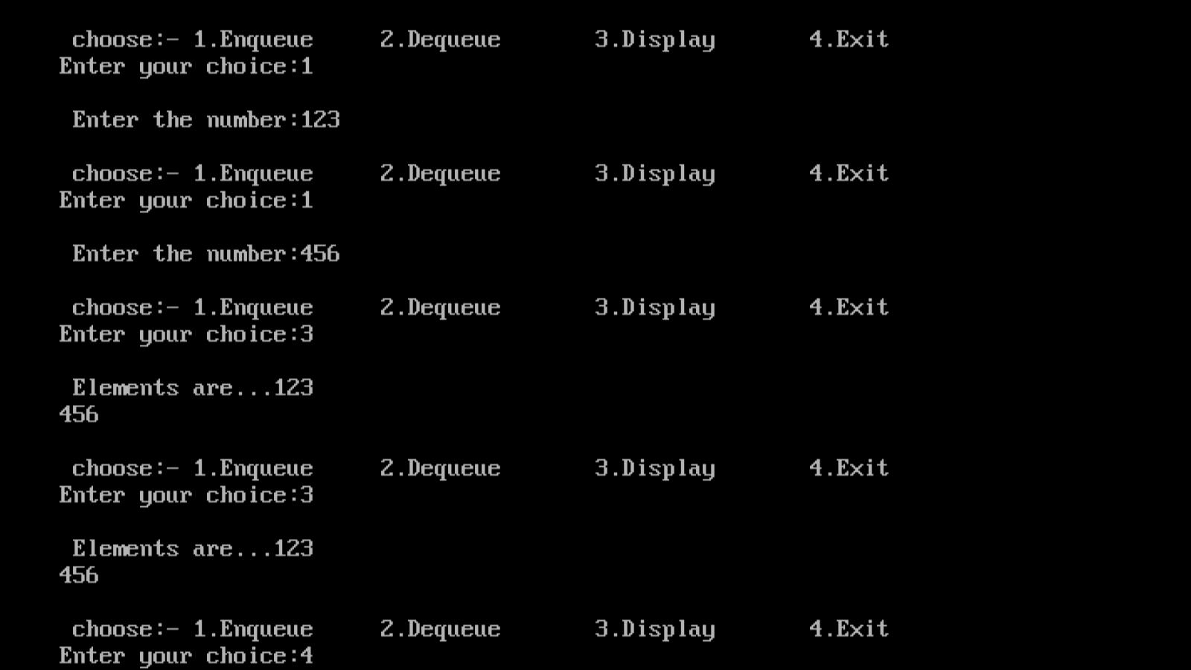

Result:

Thus the program was successfully executed and the output was verified.

EX.NO.10 PRIORITY QUEUE

AIM

To write a c program to perform priority queue operation.
ALGORITHM
- Create an empty priority queue.
- If(n>0) return TRUE
Else return FALSE
If(!isEmpty(q,n) return an instance of the largest element in q
Else return error
If(!isEmpty(q,n))return an instance of the largest element in q and
Remove it from the heap else return error
Insert item into pq and return the resulting priority queue
PROGRAM CODING:

#include<stdio.h
#include<stdlib.h>
#include<conio.h>
#define MAX 5
void insert_by_priority(int);
void delete_by_priority(int);
void create();
void check(int);
void display_pqueue();
int pri_que[MAX];
int front,rear;
void main()
{
int n,ch;
clrscr();
printf("\n1-Insert an element into a queue");
printf("\n2-Delete an element from a queue");
printf("\n3-Display queue elements");
printf("\n4-Exit");
create();
while(1)
{
printf("\n Enter your choice:");
scanf("%d",&ch);
switch(ch)
{
case 1:
printf("\n Enter value to be inserted:");
scanf("%d",&n);
insert_by_priority(n);
break;
case 2:
printf("\n Enter value to delete:");
scanf("%d",&n);
delete_by_priority(n);
break;
case 3:
display_pqueue();
break;
case 4:
printf("\n End");
exit(0);
default:
printf("\n Choice is incorrect,Enter a correct choice");
}
}
}
void create()
{
front=rear=-1;
}
void insert_by_priority(int data)
{
if(rear>=MAX-1)
{
printf("\n Queue overflow no more elements can be inserted");
return;
}
if((front==-1)&&(rear==-1))
{
front++;
rear++;
pri_que[rear]=data;
return;
}
else
check(data);
rear++;
}
void check(int data)
{
int i,j;
for(i=0;i<=rear;i++)
{
if(data>=pri_que[i])
{
for(j=rear+1;j>i;j--)
{
pri_que[j]=pri_que[j-1];
}
pri_que[i]=data;
return;
}
}
pri_que[i]=data;
}
void delete_by_priority(int data)
{
int i;
if((front==-1)&&(rear==-1))
{
printf("\n Queue is empty no elements to delete");
return;
}
for(i=0;i<=rear;i++)
{
if(data==pri_que[i])
{
for(;i<rear;i++)
{
pri_que[i]=pri_que[i+1];
}
pri_que[i]=-99;
rear--;
if(rear==-1)
front=-1;
return;
}
}
printf("\n %d not found in queue to delete",data);
}
void display_pqueue()
{
if((front==-1)&&(rear==-1))
{
printf("\n Queue is empty");
return;
}
for(;front<=rear;front++)
{
printf("%d",pri_que[front]);
}
front=0;
}

OUTPUT:

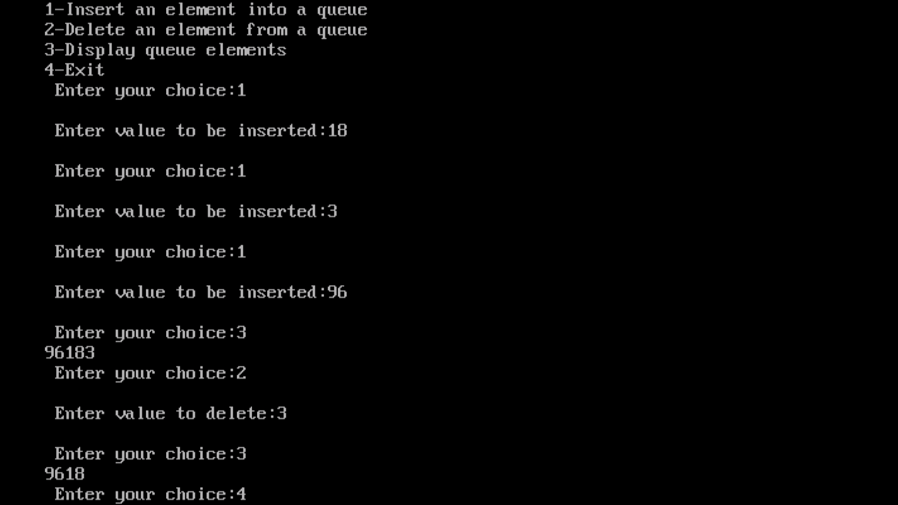

Result:

Thus the program was successfully executed and the output was verified.
EX.NO.11) DEQUE
AIM
To write a C program to illustrate the concept of deque

ALGORITHM

Step1: Start the programm
Step2: Call the main menu
Step3: Get the choice using switch case statement
Step4: Call the add function from the main menu
Step5: Get the value of n and assign it to the temp of dates
Step6: If front==null equal it to temp else assign temp to link of rear
Step7: Call the delete function
Step8:If front=rear, then through the data of front
Step9: Else transfer the data of the pointer
Step10: Call the display function
Step11: Assign ptr=null and temp as front
Step12:While temp=ptr then print the values of temp
Step13:End display function
Step14: End the program

Inserting Element:
Position : End of Deque
Check whether the Deque is full or not .
- Check whether the element is the first to be added.
  - If it is true then set the values of front and rear to zero.
- Insert the given element.
Position : Beginning of Deque
Check whether the Deque is full or not .
Check whether the element is the first to be added.
  - If it is true then set the values of front and rear t6o zero.
  - If false then do the following steps:
      - To Shift the element(s) to the right , first we have obtain the total number of elements present in the Deque.
      - Next we to obtain the position of the last element in the Deque i.i., the element in the rear end.
      - Insert the given element in the Zero ^{th} position.

Deleting Element:
Position : Beginning of Deque
Check whether the Deque is empty or not .
    - An element is removed from the front position
    - The index of the next element is stored in the front pointer.
    - So that the value of front in incremented by one.
Position : End of Deque
      - Check whether the Deque is empty or not .
      - An element is removed from the end position.
      - The index of the next element is stored in the rear pointer.
      - So that the value of rear is decremented by one.
PROGRAM CODING:
#include<stdio.h>
#include<conio.h>
#define MAX 100
void insert(int);
int delstart();
int delend();
int queue[MAX];
int rear=0,front=0;
void display();
void insertend(int);
void insertstart(int);
int main()
{
char ch,a='y';
int choice,c,token;
clrscr();
printf("\n Enter your choice for which deque operation you want to perform operation");
do
{
printf("\n1.Input_restricted deque");
printf("\n2.Output_restricted deque");
printf("\n Enter your choice for the operation:");
scanf("%d",&c);
switch(c)
{
case 1:
printf("\n Do operation in Input_restricted c deque");
printf("\n1.Insert \n2.Delete from end \n3.Delete from begining \n4.Show or Display");
do
{
printf("\n Enter your choice for the operation in c deque:");
scanf("%d",&choice);
switch(choice)
{
case 1:insertend(token);
display();
break;
case 2:token=delend();
printf("\n The token deleted is %d",token);
display();
break;
case 3:token=delstart();
printf("\n The token deleted is %d",token);
display();
break;
case 4:display();
break;
default:printf("\n Wrong choice");break;
}
printf("\n Do you want to continue(y/n)to do operation in input restricted c que:");
ch=getch();
}while(ch=='y'||ch=='y');
getch();
break;
case 2:
printf("\n Operation in Output_restricted c deque");
printf("\n1.Insert at the end\n2.Insert at the begining\n3.delete the element\n4.show or display");
do
{
printf("\n Enter your choice for the operation");
scanf("%d",&choice);
switch(choice)
{
case 1:insertend(token);
display();
break;
case 2:insertstart(token);
display();
break;
case 3:token=delstart();
printf("\n The token deleted is %d",token);
display();
break;
case 4:display();
break;

default:printf("\n Wrong choice");
break;
}
printf("\n Do you want to continue(y/n) to do operation in input restricted c que:");
ch=getch();
}while(ch=='y'||ch=='y');
getch();
break;
}
printf("\n Do you want to continue(y/n):");
ch=getch();
}while(ch=='y'||ch=='y');
getch();
}
void display()
{
int i;
printf("\n The queue elements are:");
for(i=rear;i<front;i++)
{
printf("%d",queue[i]);
}
}
void insertend(int token)
{
char a;
if(front==MAX/2)
{
printf("\n Queue full \n you cannot enter more elements at the end of c queue:");
return;
}
do
{
printf("\n Enter the token to be inserted:");
scanf("%d",&token);
queue[front]=token;
front=front+1;
printf("\n Do you want to continue insertion y/n");
a=getch();
}while(a=='y');
}
void insertstart(int token)
{
char a;
if(front==MAX/2)
{
printf("\n Queue full \n you cannot more elements at the start of queue");
}
do
{
printf("\n Enter the token to be inserted");
scanf("%d",&token);
rear=rear-1;
queue[rear]=token;
printf("\n Do you want to continue insertion y/n");
a=getch();
}while(a=='y');
}
int delend()
{
int t;
if(front==rear)
{
printf("\n Queue is empty");
return 0;
}
front=front-1;
t=queue[front];
return t;
}
int delstart()
{
int t;
if(front==rear)
{
printf("\n Queue is empty:");
}
rear=rear+1;
t=queue[rear-1];
return t;
}

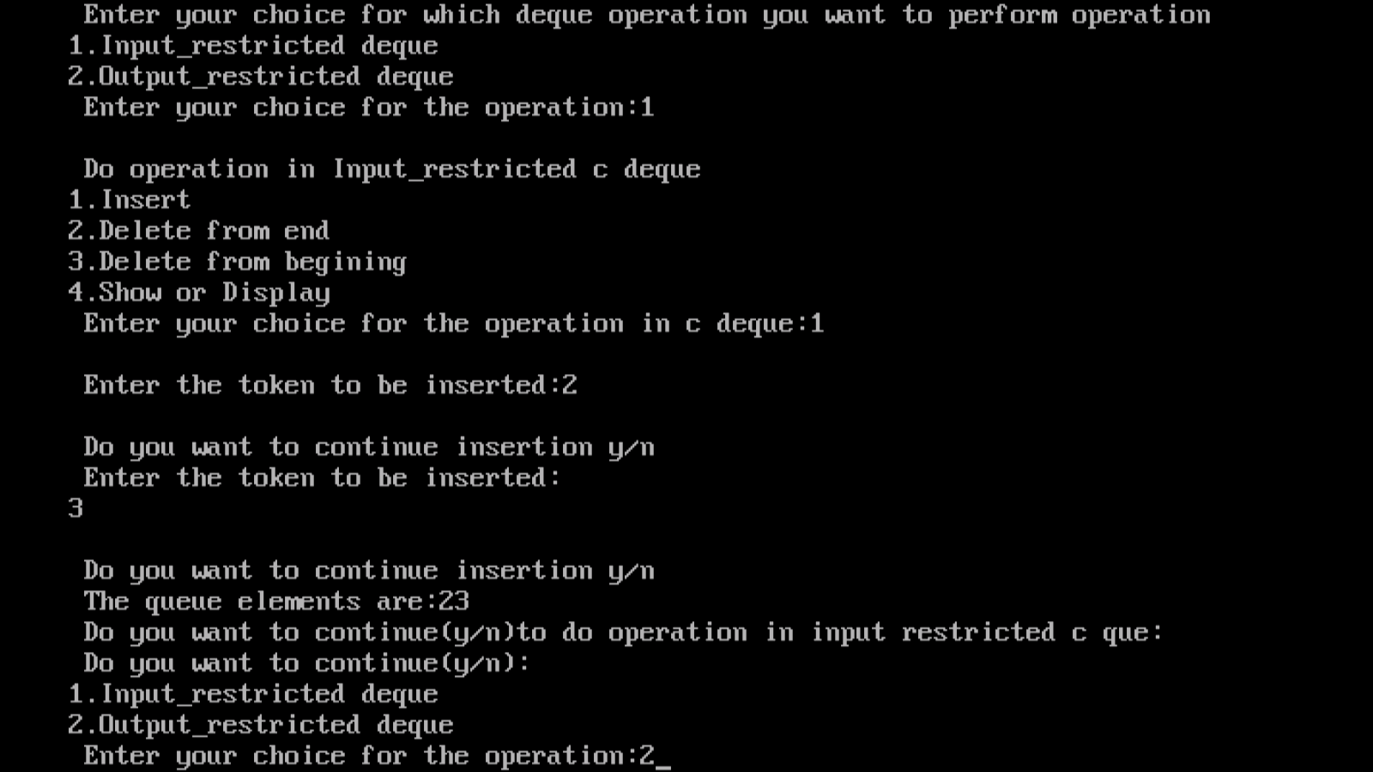
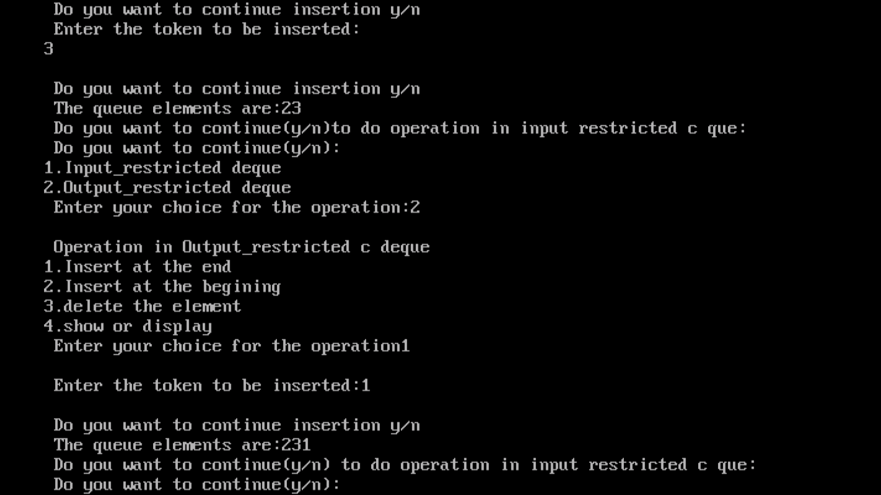
OUTPUT:

Result:

Thus the program was successfully executed and the output was verified.

EX.NO.12 SINGLY LINKED LIST
AIM To write a C program to create a singly linked list, insert the elements into that list and delete elements from that list.
ALGORITHM
Step 1 : Start the program.
Step 2 : Create a node with structure having 2 fields- data and pointer (*next).Initially set the next pointer of the node to NULL.
Step 3 : To insert an element at the front, allocate memory, get the element and insert the element after the header. Make the new node, S1->next to point to header->next.
Step 4 : To insert an element in the middle, allocate memory, get the element and position and
insert the element at that position. Make the new node, S1->next to point to the location pointed by the previous element .
Step 5 : To insert an element at the end, allocate memory, get the element and insert the element at the end. Make the new node, S1->next to point to NULL.
Step 6 : To delete the first element, make h->next to point to the second element and free the space.
Step 7 : To delete an element in the middle, get the position and make the next pointer of the previous element to point to the next element and free the space.
Step 8 : To delete the element at the end, remove the last element, make the previous element’s next pointer to point to NULL and free the space.
Step 9 : To search for an element in the list, get the element and display whether the element is found or not.
Step 10 : Display function displays the elements in the list.
Step 11 : Stop the program.

#include<stdio.h>
#include<conio.h>
#include<alloc.h>
struct node
{
int data;
struct node *next;
}*start=NULL;
void create()
{
char ch;
do
{
struct node *new_node,*current;
new_node=(struct node *)malloc(sizeof(struct node));
printf("\n Enter the data:");
scanf("%d",&new_node->data);
new_node->next=NULL;
if(start==NULL)
{
start=new_node;
current=new_node;
}
else
{
current->next=new_node;
current=new_node;
}
printf("\n Do you want to create another:");
ch=getch();
}while(ch!='n');
}
void display()
{
struct node *new_node;
printf("The linked list:n");
new_node=start;
while(new_node!=NULL)
{
printf("%d--->",new_node->data);
new_node=new_node->next;
}
printf("NULL");
}
void main()
{
clrscr();
create();
display();
getch();
}

OUTPUT:
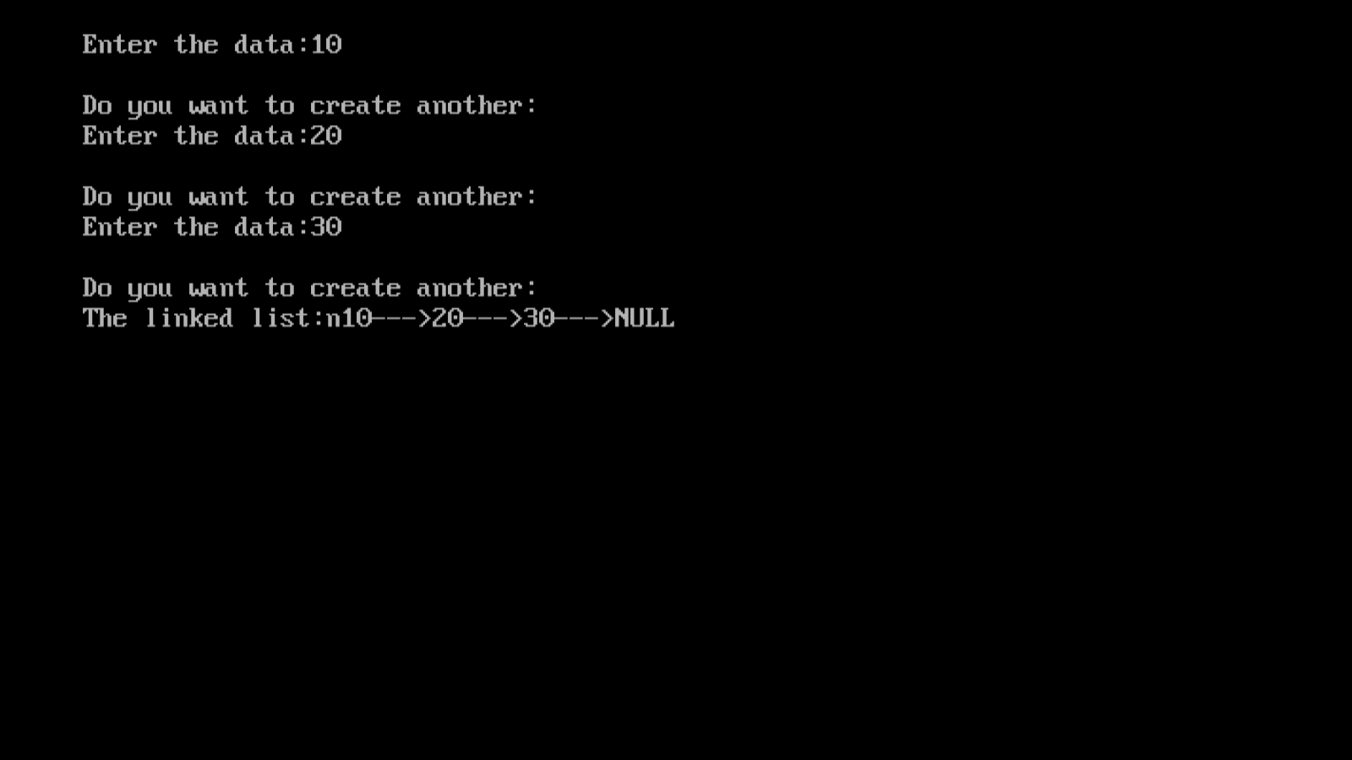

RESULT
Thus the C program to create a singly linked list, insert the elements into that list and delete elements from that list was executed and the output was verified.

EX.NO.13) DOUBLY LINKED LIST

AIM To write a C program to create a doubly linked list, insert the elements into that list and delete elements from that list .

ALGORITHM
Step 1 : Start the program.
Step 2 : Create a node with structure having 3 fields- data and 2 pointer (*prev and *next).Initially set the next pointer of the node to NULL.
Step 3 : To insert an element at the front, allocate memory, get the element and insert the element after the header. Make the new node, S1->next to point to header->next. Make the previous pointer S1->prev to point to the header.
Step 4 : To insert an element in the middle, allocate memory, get the element and position and
insert the element at that position. Make the new node, S1->next to point to the location pointed by the previous element . Make the previous pointer to point to the previous element.
Step 5 : To insert an element at the end, allocate memory, get the element and insert the element at the end. Make the new node, S1->next to point to NULL. Make the previous pointer to point to the former last element.
Step 6 : To delete the first element, make h->next to point to the second element , make the previous pointer point to the header and free the space.
Step 7 : To delete an element in the middle, get the position and make the next pointer of the previous element to point to the next element , the previous pointer to point to the element preceding the deleted element and free the space.
Step 8 : To delete the element at the end, remove the last element, make the previous element’s next pointer point to NULL and free the space.
Step 9 : To search for an element in the list, get the element and display whether the element is found or not.
Step 10 : Display function displays the elements in the list.
Step 11 : Stop the program.

PROGRAM CODING:
#include<conio.h>
#include<stdio.h>
struct doubly
{
struct doubly *front;
struct doubly *back;
int i;
};
void main()
{
struct doubly *head=0;
struct doubly *last=0;
struct doubly *p=0;
struct doubly *temp=0;
int ch,intch,user,cnt=0,t,add;
clrscr();
printf("\n\t 1. CREATE.");
printf("\n\t 2. INSERT.");
printf("\n\t 3. DELETE.");
printf("\n\t 4. DISPLAY.");
printf("\n\t 5.EXIT.");
scanf("%d",&ch);

while(ch!=5)
{
if(ch==1)
{
cnt=0;
head=(struct doubly *)malloc(sizeof(struct doubly));
head->back=0;
head->front=0;
printf("\n\t ENTER DATA::: ");
scanf("%d",&head->i);
cnt++;
last=head;
}
if(ch==2)
{

printf("\n\t 1. INSERTION AT FRONT.");
printf("\n\t 2. INSERTION AT MIDDLE.");
printf("\n\t 3. INSERTION AT END.");
scanf("%d",&intch);
temp=(struct doubly *)malloc(sizeof(struct doubly));
printf("\n\t ENTER DATA:::");
scanf("%d",&temp->i);

if(intch==1)
{
temp->front=0;
temp->back=head;
head=temp;
cnt++;
}
if(intch==3)
{
p=head;
while(p->back!=0)
{
p=p->back;
}
temp->back=0;
temp->front=p;
p->back=temp;
cnt++;
}
if(intch==2)
{
printf("\n\tENTER VALUE BETWEEN 1--%d",cnt);
scanf("%d",&add);
t=1;
p=head;
while(t<add)
{
p=p->back;
t++;
}
temp->back=p->back;
p->back->front=temp;
p->back=temp;
temp->front=p;

}
}
if(ch==4)
{
p=head;
while(p!=0)
{
printf("\t-->%d",p->i);
p=p->back;
}
printf("\n\t total nodes %d",cnt);
}
if(ch==3)
{
printf("\n\t1. DELETE FRONT");
printf("\n\t2. DELETE MIDDLE");
printf("\n\t3. DELETE END");
scanf("%d",&intch);
if(intch==1)
{

head->back=t;
free(head);
head=t;
head->front=0;
cnt--;
}
if(intch==3)
{
p=head;
while(p->back!=0)
{
p=p->back;
}
temp->front=p;
p->back=temp;
temp->back=0;
cnt--;
}
if(intch==2)
{
printf("\n\tENTER VALUE BETWEEN 1--%d",cnt);
scanf("%d",&add);
t=1;
p=head;
while(t<(add-1))
{
p=p->back;
t++;
}
temp=p->back;
p->back=temp->back;
temp->back->front=p;
free(temp);

}

}
printf("\n\t 2. INSERT.");
printf("\n\t 3. DELETE.");
printf("\n\t 4. DISPLAY.");
printf("\n\t 5.EXIT.");
scanf("%d",&ch);
}
getch();

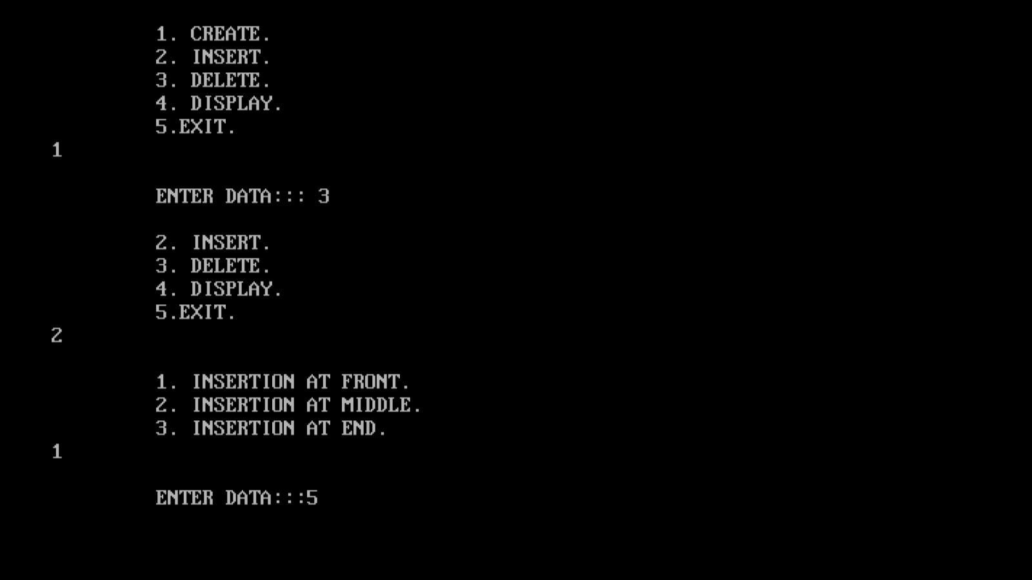
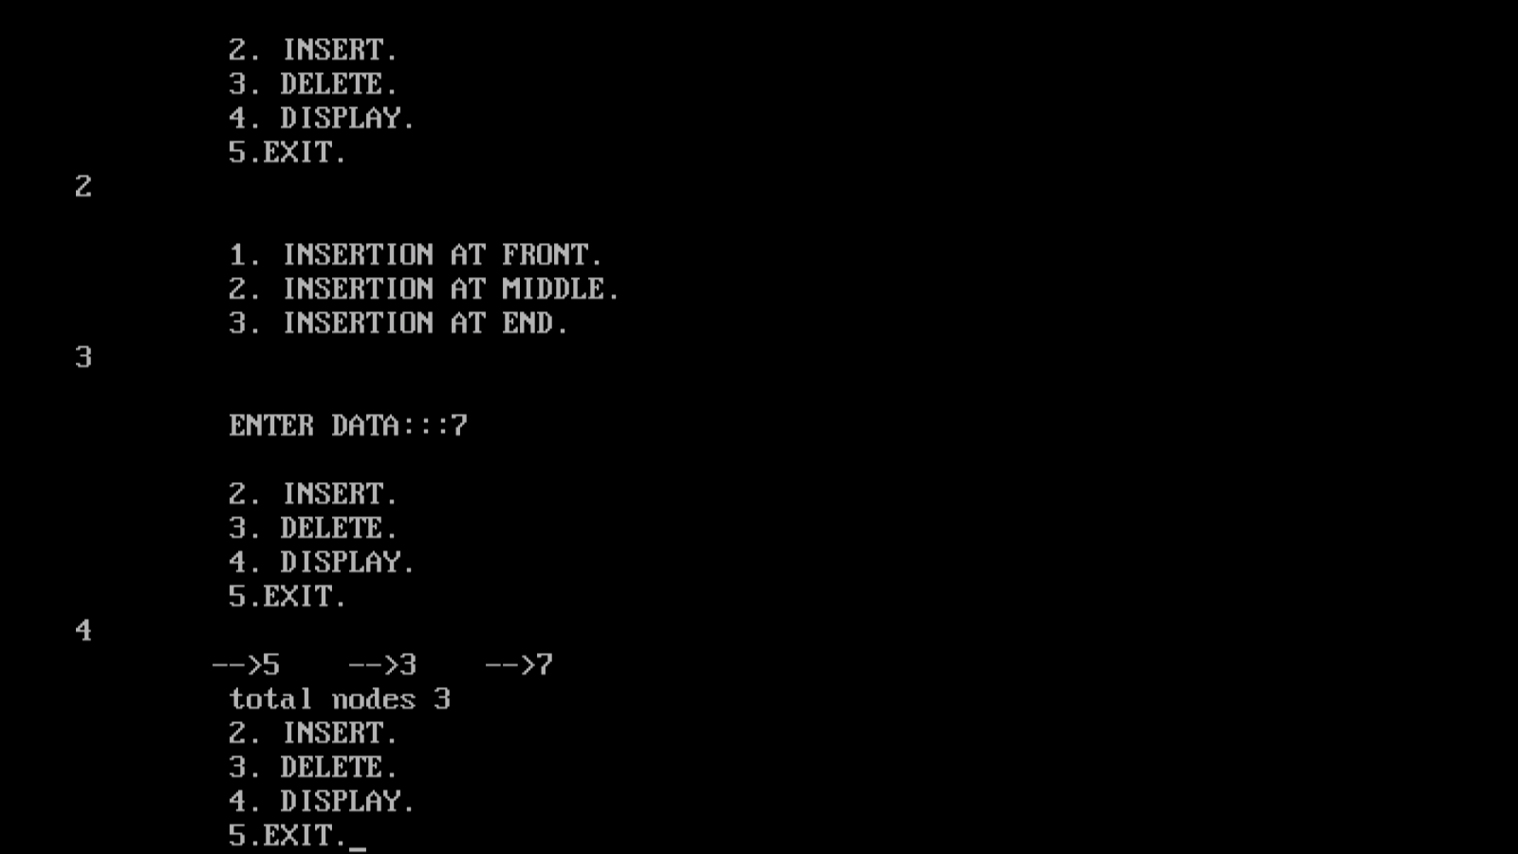
OUTPUT:

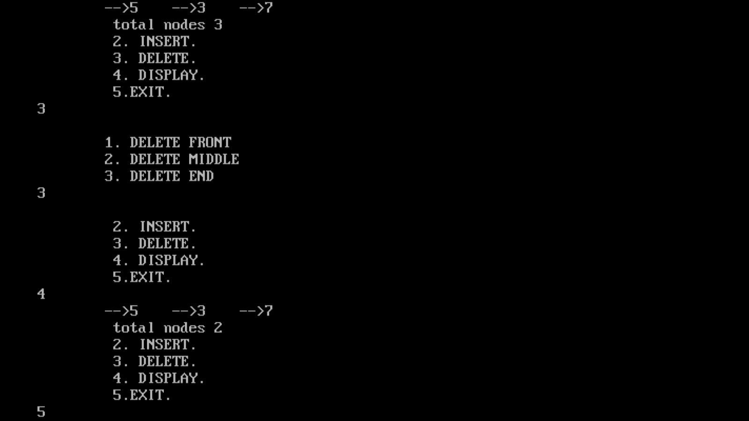

RESULT
Thus the C program to create a doubly linked list, insert the elements into that list and delete elements from that list was executed and the output was verified.

EX.NO.14 CIRCULAR LINKED LIST
AIM To write a C program to create a Circular linked list, insert the elements into that list and delete elements from that list

ALGORITHM
Step 1 : Start the program.
Step 2 : Create a node with structure having 2 fields- data and pointer (*next).Initially set the next pointer of the node to point to the header.
Step 3 : To insert an element at the front, allocate memory, get the element and insert the element after the header. Make the new node, S1->next to point to header->next.
Step 4 : To insert an element in the middle, allocate memory, get the element and position and
insert the element at that position. Make the new node, S1->next to point to the location pointed by the previous element.
Step 5 : To insert an element at the end, allocate memory, get the element and insert the element at the end. Make the new node, S1->next to point to the header.
Step 6 : To delete the first element, make h->next to point to the second element and free the space.
Step 7 : To delete an element in the middle, get the position and make the next pointer of the previous element to point to the next element and free the space.
Step 8 : To delete the element at the end, remove the last element, make the previous element’s next pointer to point to the header and free the space.
Step 9 : To search for an element in the list, get the element and display whether the element is found or not.
Step 10 : Display function displays the elements in the list.
Step 11 : Stop the program
PROGRAM CODING:
#include<stdio.h>
#include<malloc.h>
struct node
{
int info;
struct node *next;
}*h;
void create(struct node *);
void insertfront(struct node *,int);
void insertmiddle(struct node *,int);
void insertend(struct node *,int);
void deletefront(struct node *);
void deletemiddle(struct node *);
void deleteend(struct node *);
void search(struct node *);
void display(struct node *);
void main()
{
struct node *h;
int n,s,op;
clrscr();
h=(struct node *)malloc(sizeof(struct node *));
printf("\n\n\n\n\t\t\t\t Linked list operation");
printf("\n\n\t1.Create\n\t2.Insert front\n\t3.Insert middle\n\t4.Insert end\n");
printf("\n\t5.Delete front\n\t6.Delete middle\n\t7.Delete end\n\t8.search\n\t9.Display\n\t10.Exit\n");
while(1)
{
printf("\n Enter your option:\t");
scanf("%d",&op);
switch(op)
{
case 1:create(h);break;
case 2:
printf("\n Enter the number to insert:\t");
scanf("%d",&n);
insertfront(h,n);
break;
case 3:
printf("\n Enter the number to insert:\t");
scanf("%d",&n);
insertmiddle(h,n);
break;
case 4:
printf("\n Enter the number to insert:\t");
scanf("%d",&n);
insertend(h,n);
break;
case 5:
deletefront(h);
break;
case 6:
deletemiddle(h);
break;
case 7:
deleteend(h);
break;
case 8:
search(h);
break;
case 9:
display(h);
break;
case 10:
exit(0);
break;
default:printf("\n.....Invalid option\n");
}
}
}
void create(struct node *h)
{
int i,n,x;
struct node *s1,*s2;
s1=(struct node *)malloc(sizeof(struct node *));
printf("\n Enter the number of elements:\t");
scanf("%d",&x);
printf("\n Enter the element:\t");
scanf("%d",&n);
s1->info=n;
s1->next=h;
h->next=s1;
for(i=0;i<x-1;i++)
{
s2=(struct node *)malloc(sizeof(struct node *));
s1->next=s2;
printf("\n Enter the element:\t");
scanf("%d",&n);
s2->info=n;
s2->next=h;
s1=s1->next;
}
display(h);
printf("\n");
}
void insertfront(struct node *h,int n)
{
struct node *x;
x=(struct node *)malloc(sizeof(struct node *));
x->info=n;
x->next=h->next;
h->next=x;
display(h);
printf("\n");
}
void insertmiddle(struct node *h,int n)
{
struct node *x,*y;
int e;
x=(struct node *)malloc(sizeof(struct node *));
x->info=n;
x->next=h;
printf("\n Enter the element after which the given element to be inserted:\t");
scanf("%d",&e);
y=h;
while(y->info!=e)
y=y->next;
x->next=y->next;
y->next=x;
display(h);
}
void insertend(struct node *h,int n)

{
struct node *x,*y;
x=(struct node *)malloc(sizeof(struct node *));
x->info=n;
x->next=h;
y=h;
while(y->next!=h)
y=y->next;
y->next=x;
display(h);
}
void deletefront(struct node *h)
{
if(h->next!=h)
h->next=h->next->next;
else
h=h;
display(h);
}
void deletemiddle(struct node *h)
{
int e;
struct node *x,*y;
y=h;
x=y->next;
printf("\n Enter the element \t");
scanf("%d",&e);
while(x->info!=e)
{
x=x->next;
y=y->next;
}
y->next=x->next;
display(h);
}
void deleteend(struct node *h)
{
struct node *x,*y;
y=h;
x=y->next;
while(x->next=h)
{
x=x->next;
y=y->next;
}
y->next=h;
display(h);
}
void search(struct node *h)
{
struct node *x,*y;
int s;
printf("\n Enter the number:\t");
scanf("%d",&s);
y=h;
while(y->info!=s&&y->next!=h)
y=y->next;
if(y->info==s)
printf("Element found\n");
else
printf("Element not found \n");
}
void display(struct node *h)
{
struct node *y;
y=h;
printf("h->");
while(y->next!=h)
{
y=y->next;
printf("%d->",y->info);
}
printf("h");
}

OUTPUT:
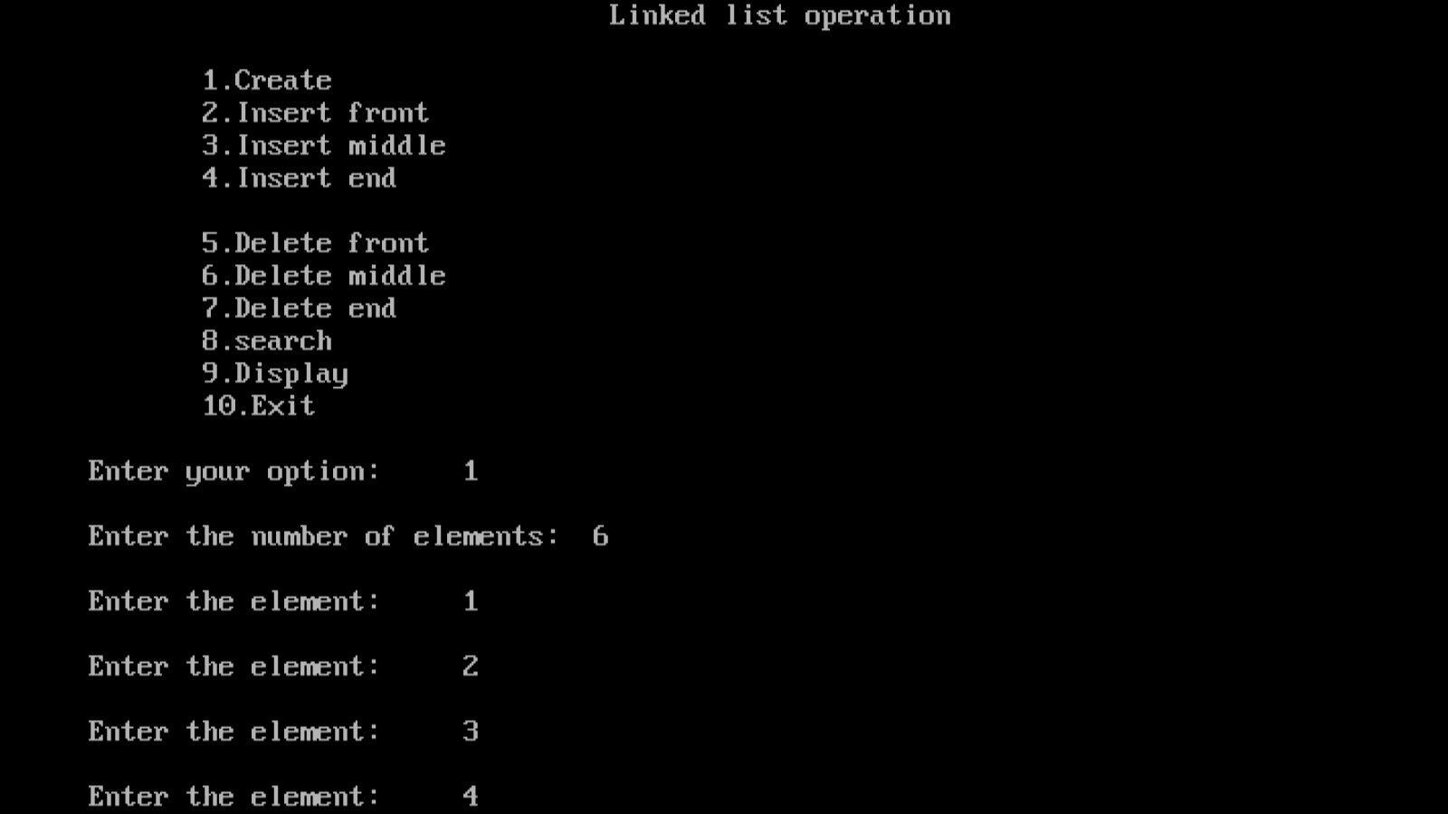
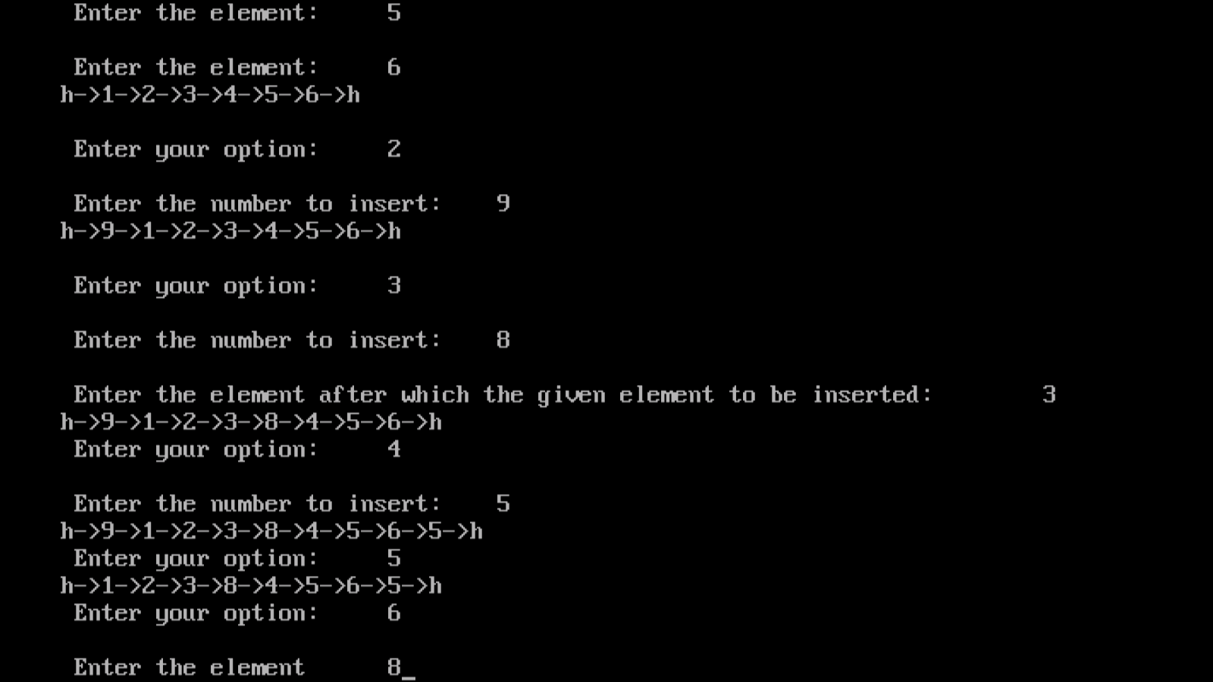

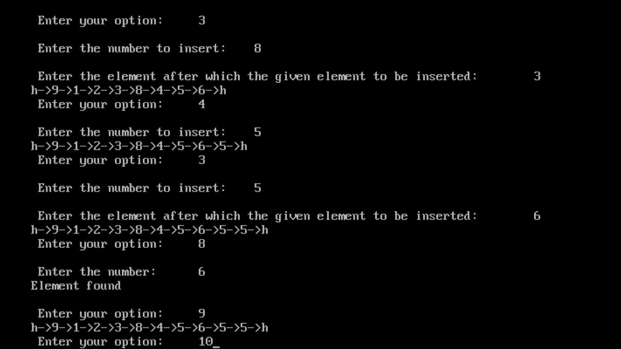

RESULT
Thus the C program to create a Circular linked list, insert the elements into that list and delete elements from that list was executed and the output was verified.

EX.NO.15 TREE TRAVERSAL TECHNIQUES
AIM
To write a C Program to
- create a binary tree of integers
- Traversing the above binary tree in preorder, inorder and post order

ALGORITHM

Step 1: Start

Step 2: Define a structure btree

Step 3: Type define struct btree as node

Step 4: While(tree), begin

Step 5: Print MENU

Step 6: Write your choice

Step 7: If choice=1

Step 8: Enter your no of nodes

Step 9:Read nodes n

Step 10: for i=1 to n in steps of 1 do

Step 11: Print enter item

Step 12: Read item

Step 13: Root =call create (root, item).end for

Step 14: if choice=2

Step15: Read element to be deleated

Step 16: Call delete(root, item) end for

Step 17: If choice=3

Step 18: Call preorder(root)

Step 19: Call postorder(root)

Step 20: Call inorder(root)

Step 21: Break, end of switch

Step 22: Stop

For insert function

Step 1: Start

Step 2: If t= null

Step 3: Allocate memory to temp

Step 4: Temp->data =item

Step 5: Temp-> lc=null

Step 6: Temp->rc=null

Step 7: return t to main and end

Step 8: If item< (l->data)

Step 9: T->lc=call insert(e->lc, t)

Step 10: T->rc=call isert(e->lc,t)

Step 11:Return t

Step 12: Stop

For deletion function

Step 1: Start

Step 2: x=d

Step 3: while x!=null

Step 4: If x->data =t

Strep 5:Break

Step 6: Parent =x

Step 7: if t<x->data

Step 8: t=t→lc

Step 9: t=l→rc

Step 10: If x→lc!=null &&x→rc!=null

Step11: parent =x

Step12: If parent==null

Step 13: parent→lc==null

Step 14: parent→rc==null

Step 15: If p->lc=x->rc

Step 16: If p->rc=x->rc

Step 17: While insert->lc=null

Step 18: Insert=insert->la

Step 19:x->data=insert->data

Step 20:x=insert

Step 21: Return d

Step 22: Stop

for inorder function

Step 1: Start

Step 2: If t!=null

Step 3: Call inorder(t->lc)

Step 4: Write t->data

Step 5: Call inorder(t->rc)

Step 6: Stop

for postorder function

Step 1: Start

Step 2: If t!=null

Step 3: Call postorder(t->lc)

Step 4: Call postorder(t->rc)

Step 5: Write data

Step 6: Stop

for preorder function

Step 1: Start

Step 2: If t!=null

Step 3: Write data

Step 4: Call postorder(t->lc)

Step 5: Call postorder(t->rc)

Step 6: Stop
PROGRAM CODING:
#include<stdio.h>
#include<malloc.h>
struct node
{
int value;
struct node*left,*right;
};
struct node*root,*new1;
void insert(struct node*,struct node*);
void preorder(struct node*);
void inorder(struct node*);
void postorder(struct node*);
int main()
{
int ch,v;
clrscr();
root=(struct node*)malloc(sizeof(struct node));
printf("Enter the value of root:");
scanf("%d",&root->value);
root->left=root->right=NULL;
printf("\n\t.......TREE TRAVERSAL....\n\t");
printf("\n\t1.insert\n\t2.preorder\n\t3.postorder\n\t4.inorder\n\t5.exit");
while(1)
{
printf("\n enter your option:");
scanf("%d",&ch);
switch(ch)
{
case 1:
new1=(struct node*)malloc(sizeof(struct node));
printf("Enter the valueto be inserted\t");
scanf("%d",&new1->value);
new1->left=new1->right=NULL;
insert(root,new1);
break;
case 2:
printf("\n pre order traversal:");
preorder(root);
break;
case 3:
printf("\n post order traversal:");
postorder(root);
break;
case 4:
printf("\n in order traversal:");
inorder(root);
break;
case 5:
exit(0);
break;
}
}
}

void preorder(struct node*root)
{
if(root!=NULL)
{
printf("\n%d",root->value);
preorder(root->left);
preorder(root->right);
}
}

void inorder(struct node*root)
{
if(root!=NULL)
{
inorder(root->left);
printf("\n%d",root->value);
inorder(root->right);
}
}

void postorder(struct node*root)
{
if(root!=NULL)
{
postorder(root->left);
postorder(root->right);
printf("\n%d",root->value);
}
}
void insert(struct node *root,struct node* new1)
{
if(new1->value<root->value)
{
if(root->left==NULL)
root->left=new1;
else
insert(root->left,new1);
}
if(new1->value>root->value)
{
I f(root->right==NULL)
root->right=new1;
else
insert(root->right,new1);
}
}

OUTPUT:
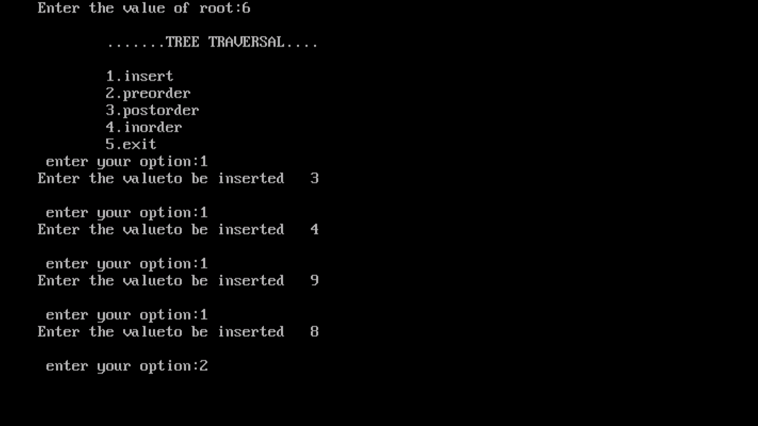
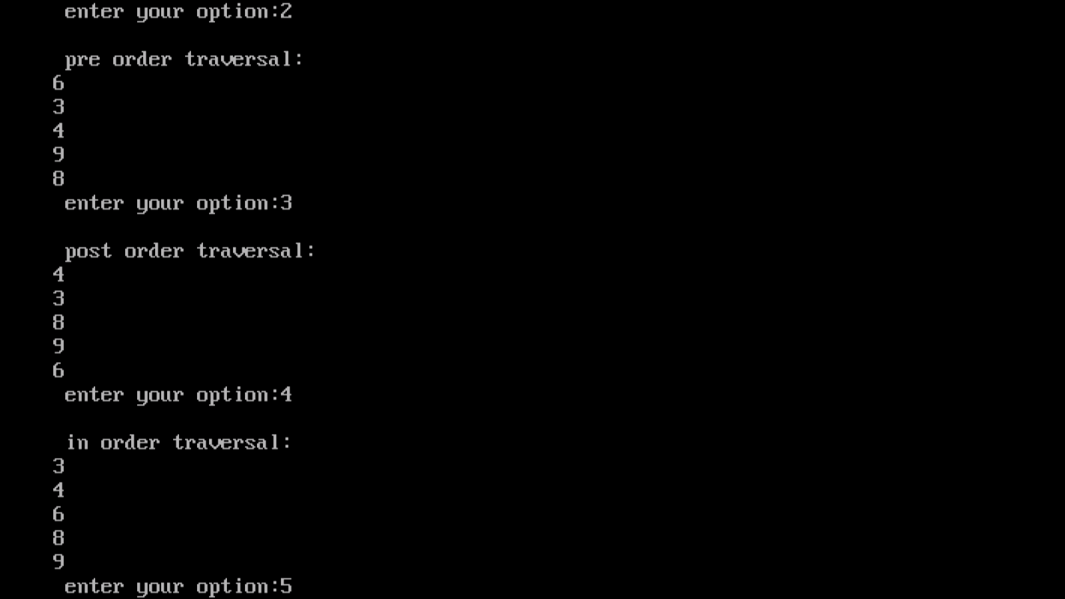

Result:
Thus the program was successfully executed and the output was verified.
EX.NO.16 BREADTH FIRST SEARCH
AIM

To write a C program to illustrate the concept of Breadth First Search.

ALGORITHM

Step1. Start the program
Step2. Declare the variables used
Step3. Procedure BFS(V)
Step4. VISITED(V)=1
Step5. Initialise q to be empty
Step6. LOOP
For all vertices W adjacent to V do
If VISITED(W)=0 then
Call ADD Q(W,Q)
VISITED(W)=1
End
Step7. If q is empty then
Return
Step8. Call DELETE Q(V,Q)
For ever
Step9. End BFS
Step10.Stop the program

PROGRAM CODING:

#include<stdio.h>
#include<conio.h>
int a[20][20],q[20],visited[20],n,i,j,f=0,r=-1;
void bfs(int v)
{
for(i=1;i<=n;i++)
if(a[v][i] && !visited[i])
q[++r]=i;
if(f<=r)
{
visited[q[f]]=1;
bfs(q[f++]);
}
}
void main()
{
int v;
clrscr();
printf("\n Enter the number of vertices:");
scanf("%d",&n);
for(i=1;i<=n;i++)
{
q[i]=0;
visited[i]=0;
}
printf("\n Enter graph data in matrix form:\n");
for(i=1;i<=n;i++)
for(j=1;j<=n;j++)
scanf("%d",&a[i][j]);
printf("\n Enter the starting vertex:");
scanf("%d",&v);
bfs(v);
printf("\n The node which are reachable are:\n");
for(i=1;i<=n;i++)
if(visited[i])
printf("%d\t",i);
getch();
}
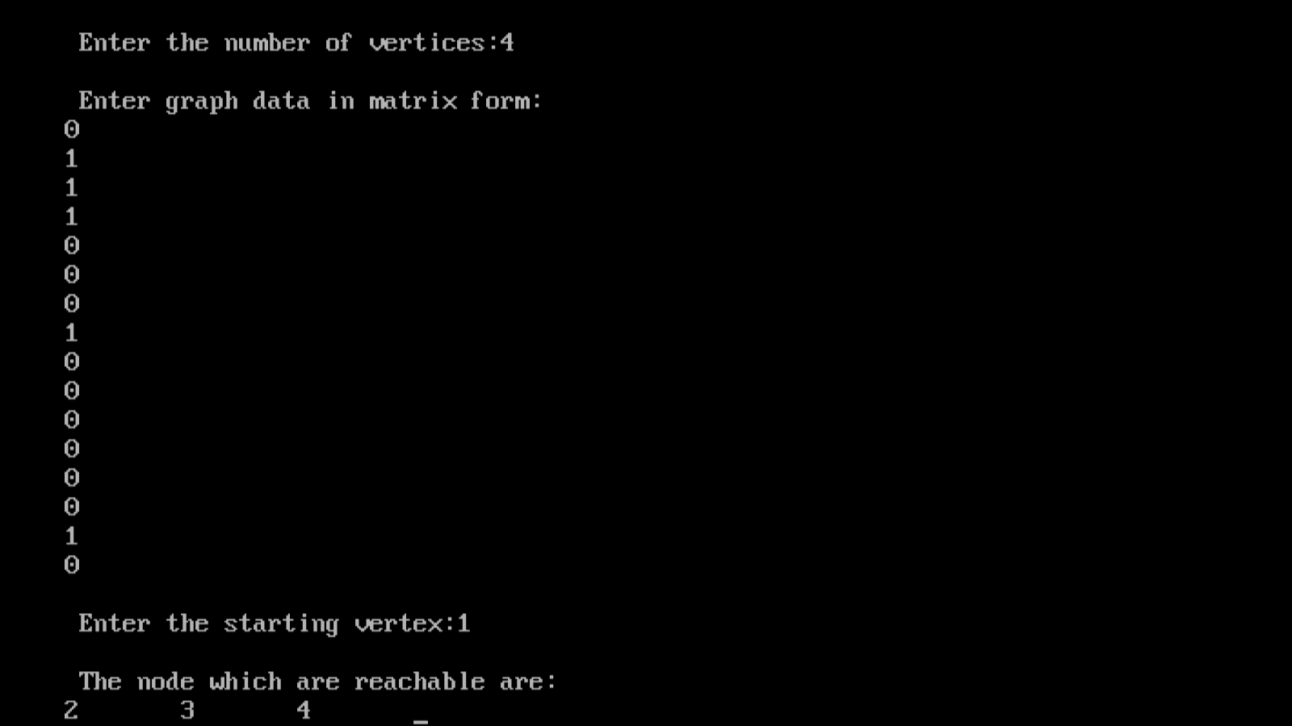
OUTPUT

Result: Thus the program was successfully executed and the output was verified.
EX.NO.17 DEPTH FIRST SEARCH
AIM

To write a C program to illustrate the concept of Depth First Search.

.
PROGRAM CODING:

#include<stdio.h>
#include<conio.h>
int a[20][20],reach[20],n;
void dfs(int v)
{
int i;
reach[v]=1;
for(i=1;i<=n;i++)
if(a[v][i] && !reach[i])
{
printf("\n %d->%d",v,i);
dfs(i);
}
}
void main()
{
int i,j,count=0;
clrscr();
printf("\n Enter number of vertices:");
scanf("%d",&n);
for(i=1;i<=n;i++)
{
reach[i]=0;
for(j=1;j<=n;j++)
a[i][j]=0;
}
printf("\n Enter the adjacency matrix:\n");
for(i=1;i<=n;i++)
for(j=1;j<=n;j++)
scanf("%d",&a[i][j]);
dfs(1);
printf("\n");
for(i=1;i<=n;i++)
{
if(reach[i])
count++;
}
if(count==n)
printf("\n Graph is connected");
else
printf("\n Graph is not connected");
getch();
}

OUTPUT:

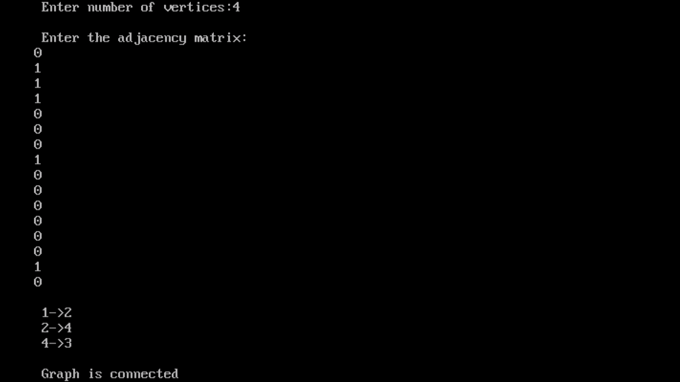

Result:

Thus the program was successfully executed and the output was verified.

